Initial Design Report 2

FSAE Suspension
Competition Team Number 072
Lumberjack Racing

Parker Johnson: Suspension Design Lead
Chris Laney: Brakes Engineer
Garrett Pearson: A-Arm Engineer
Mathew Cusson: Steering Engineer
Joseph Ciao: Pushrod Assembly Engineer

Fall 2024-Spring 2025

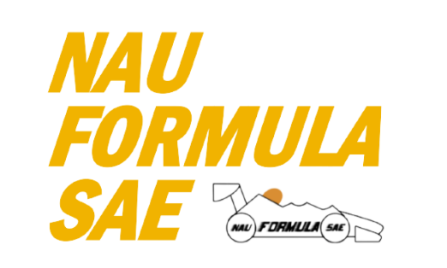

Project Sponsor: Northern Arizona University
Faculty Advisor: Constantin Ciocanel
Instructor: David Willy

TABLE OF CONTENTS
Contents
TABLE OF CONTENTS 3
DISCLAIMER 4
EXECUTIVE SUMMARY 2
1.1 Project Description(Chris) 2
1.2 Deliverables(Chris) 2
1.3 Success Metrics(Joseph) 3
2 REQUIREMENTS (Parker Johnson) 4
2.1 Customer Requirements (Parker Johnson) 4
2.2 Engineering Requirements (Parker Johnson) 4
2.3 House of Quality (HoQ)(Joseph) 5
3 Research Within Your Design Space 6
3.1 Benchmarking 6
3.1.1 A-Arm/General Measurements (Garrett Pearson) 6
3.1.2 Brakes (Chris Laney) 6
3.1.3 Pushrod/Dampers (Joseph Ciao) 7
3.1.4 Steering (Matthew Cusson) 7
3.2 Literature Review 7
3.2.1 Suspension Geometry & Steering Knuckle Literature review (Parker Johnson) 7
3.2.2 Brakes Literature Review - Chris Laney 8
3.2.3 A-Arm Literature Review (Garrett Pearson) 9
3.2.4 Steering Literature Review (Mathew Cusson) 9
3.2.5 Pushrod Literature Review (Joseph Ciao) 10
3.3 Mathematical Modeling 11
3.3.1 Parker Johnson 11
3.3.2 Brakes - Chris Laney 15
3.3.3 A-Arm Garrett Pearson 19
4 Design Concepts 23
4.1 Functional Decomposition 23
4.2 Concept Generation 23
4.2.1 Steering Knuckles (Parker Johnson) 23
4.2.2 Brakes Assembly (Chris Laney) 24
4.2.3 Steering Assembly – Matthew Cusson 26
4.2.4 Rocker arm Design (Joseph) 28
4.3 Selection Criteria 28
4.3.1 Steering Knuckles (Parker Johnson) 28
4.3.2 Brakes Assembly – Chris Laney 28
4.3.3 Steering Assembly – Matthew Cusson 28
4.4 Concept Selection 29
4.4.1 Steering Knuckles (Parker Johnson) 29
4.4.2 Brakes Assembly (Chris Laney) 30
4.4.3 Steering Assembly (Matthew Cusson) 31
5 Schedule and Budget 31
Design Validation and Initial Prototyping 33
CONCLUSIONS 40
6 REFERENCES 41

DISCLAIMER
This report was prepared by students as part of a university course requirement. While considerable effort has been put into the project, it is not the work of licensed engineers and has not undergone the extensive verification that is common in the profession. The information, data, conclusions, and content of this report should not be relied on or utilized without thorough, independent testing and verification. University faculty members may have been associated with this project as advisors, sponsors, or course instructors, but as such they are not responsible for the accuracy of results or conclusions.

EXECUTIVE SUMMARY
This report presents the total process of designing, manufacturing, and testing the suspension components for our Lumberjack Racing’s 2025 Formula SAE vehicle. Our objective is to design a formula style race car that will not only pass tech for the competition but also perform reliably in all dynamic and static events. Building on the lessons learned from last year’s team, which placed 97th overall due to various mechanical and performance issues, we have prioritized early completion, increased testing, and improved system reliability. Through the efforts listed in this document we hope to improve in all areas of the competition in May.
Last year's vehicle faced challenges related to limited suspension adjustability, poor steering feel, and inadequate mounting points, all of which contributed to subpar performance in events. To address these, we have focused on optimizing the pushrod assembly, steering response, and damper selection to achieve better handling and control. Each member of the team has done extensive research into top team design choices to inspire our own. Every design choice has gone through decision matrices to ensure the best overall choice is made. Key challenges addressed in the report include minimizing suspension failure risks, reducing weight while maintaining strength, and improving vehicle handling.
The design process began with an in-depth assessment of customer requirements (CRs) and engineering requirements (ERs), derived from our advisor’s feedback and the Formula SAE Rulebook. Using the rules as a basis the team set certain target goals such as vehicle adjustability, suspension durability, and compliance with safety standards and converted those into a HoQ to properly weigh each requirement. The team has used modeling on various tools including MATLAB, Soildworks, Vsusp, and ANSYS to test and improve the design concepts each team member has come up with. This was used to evaluate key parameters like camber gain, toe, and King Pin Inclination (KPI). This allowed us to optimize the suspension design for improved cornering and stability under various load conditions.
The manufacturing process for our suspension components involved a combination of precision machining and hands-on fabrication. Control arms were cut and welded in-house, with careful attention to alignment and reinforcement to ensure structural integrity under load. Aluminum brackets were machined using a vertical mill, following detailed CAD drawings to maintain tight tolerances and proper fitment with the chassis and other suspension elements. Several key components, including the wheel hubs, rocker arms, and brakes, were water-jetted to achieve clean, accurate profiles and reduce manual cutting time. These parts were then post-processed to add features like tapped holes and bearing seats. For the steering system, various components were manufactured using a lathe to ensure precise diameters and concentricity, which are critical for proper steering response. Before cutting, each part was measured and marked to avoid errors, and any mistakes made during early attempts were used as learning experiences to improve our workflow. Critical mounting points and inserts were double-checked for accuracy, and the final assembly was test-fitted to ensure proper motion and clearance. This hands-on approach not only ensured quality but also gave our team a deeper understanding of how our designs translated from CAD to real-world components.

In conclusion, this report details the extensive research, modeling, and decision-making processes that have shaped our suspension design. We have made significant steps in improving the overall performance, reliability, and adjustability of the vehicle. By addressing the shortcomings of last year’s design and incorporating lessons learned from top teams, we are confident that our suspension system will contribute to a more successful competition outcome in the 2025 Formula SAE event.

Project Description (Chris)
Formula Student is an international competition that has been taking place since 1980. Universities from around the country come together to compete with their open-wheeled racing formula vehicles against one another. At this point, more than 125 universities compete yearly, and the event has expanded to several other countries. The basis of the competition is to design, test, analyze, and build a competitive race car compared to the best of other universities.

Deliverables(Chris)
The main deliverable of this project is the final designed and tested car. Throughout the semesters, there is also several reports, presentations, and other individual assignments due for the capstone class. Competition specific deliverables include the finished car, a report, and presentation. The remainder of the deliverables are client/course related and consist of assignments designed to teach the student useful skills related to the engineering design/manufacturing process.

Success Metrics(Joseph)
For this project to be deemed successful the team has a few targets in mind. Last year’s car was able to pass tech but had many troubles during competition. This meant the car was unable to compete in most of the events and only placed 97th overall. Also, the car did not do much of anything when it came to aerodynamics, which is very important when it comes to the judges and their scores. The overall goal is to have a reliable car outfitted with a complete aerodynamic package that will pass tech, be able to compete in all events, and score higher overall. Another success metric is to have the car built much earlier and do more extensive testing. This will help eliminate the reliability issues last year’s team ran into. Some key changes will include improving the adjustability of the suspension, improving steering feel and ease, and improved adjustability for suspension.

REQUIREMENTS (Parker Johnson)
This section of the report contains an assessment of the Customer Requirements given to us by our faculty advisor, Constantin Ciocanel. These requirements are vague however they give our team a good basis for fully developing a list of customer requirements that stem from the main ones given to us. From these we can produce Engineering requirements which are quantified versions of the CR’s and give our team a strong foundation for the goals of the project and hold us to the highest standard possible in the given time for this project. The Engineering Requirements cannot be produced completely from the CR’s, since there is a limited amount that can be quantified. However, it is necessary to rely on the FSAE Rulebook to give us quantifiable requirements we need to follow to pass technical inspection and have a safe vehicle that will be successful at competition.

Customer Requirements (Parker Johnson)
During the formation process of the team and initial research over the summer, a quick meeting with our faculty advisor ensued giving us a good idea of the customer requirements. This was a brief discussion and was vague, but our team was able to interpret the customer requirement into separate, non-quantifiable requirements. Our customer requirement was to successfully build a car, pass inspection, and compete in all events at competition. Since this requirement is not specific enough for the purpose of a HoQ, we had to further break this down into different requirements developed by our team to ensure our success in these areas. The main CR’s we developed that directly apply to our advisor’s CR’s are as follows: High adjustability, ease of machinability, strong components, reliable, durable, and improved ergonomics. The rest of the CR’s developed by the team are non-essential for the success in the advisor’s requirements, however we want to go above and beyond and improve the car overall in a way that potentially give our team an even higher placement in competition. See our HoQ in section 2.3 for full list of CR’s.

Engineering Requirements (Parker Johnson)
These Engineering Requirements were developed by any possible quantification of the Customer Requirements and included requirements from the FSAE 2025 Rulebook for technical inspection, since our team cannot compete if we do not meet these requirements. Most of these requirements are defined by the SAE organization to ensure a safe competition area for the driver as well as volunteers for the Formula Student class race car. There are some general requirements for dimensions of the car, such as a minimum wheelbase of 60”, and the shorter track width must not be less than 75% of larger track width of the vehicle. This should not be a problem with our car since we are predicting the same track width in the front as in the rear to be 48” wide. Another important Engineering requirement worth noting is the max Center of Gravity location, which is defined as 16”. This is to simulate a maximum lateral acceleration and prove that the vehicle will not roll over, so long as the COG is below this height. The vehicle also needs to be at a maximum of 2.75” from the ground at the lowest side impact structure, to ensure a lower CoG location. The car also needs to have at least 2” of vertical wheel travel, to demonstrate a serious attempt at a suspension system made for the vehicle. One of the main safety factors for this vehicle are the brakes, and we are required to have 2 independent circuits to prevent total brake failure, as well as a brake pedal that can withstand a force of 2000 N minimum.

House of Quality (HoQ)(Joseph)
Table 1: QFD
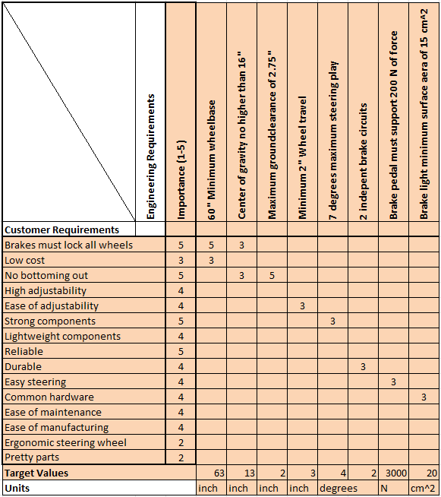

Research Within Your Design Space

Benchmarking

A-Arm/General Measurements (Garrett Pearson)
Last year's winning car out of Ohio State University used a double a-arm system which is by far the most common and most proven system FSAE teams use. This system allows for good stability at high speeds and good adjustability without a complete redesign. While most control arms found in FSAE are made of steel like Ohio State’s, some teams have run control arms made of carbon fiber. This allows for significantly reduced weight of the arms while not having to sacrifice the strength of the system but comes at a greater material cost [19]. The length of the A-arms is also an important consideration in the design process. The 2nd place team from last year's competition, University of Illinois, ran their car with a track width of 49in [20] and the third-place team, California-Berkeley, ran with a track width of 47in [21]. A generally shorter track width like the previously mentioned teams have, makes the steering response faster and the car able to turn tighter, which is important for the type of events we will be competing in. While control arms are not the only thing that contributes to track length, these measurements will give us a good idea of how long to make our a-arms so that our total track length falls around the other top teams.

Brakes (Chris Laney)
Many winning teams over the years use very similar braking set-ups, but with slight variances depending on setup. It was found that at least five of the top ten teams in the last few years used Wilwood GP200 calipers, however that number may be much higher due to the secrecy in this sort of technical information. Most teams that used different calipers front to rear used the larger of the two in the front, with a smaller corresponding master cylinder bore size. A few other popular caliper choices were the Brembo P34 and ISR 22-048, however these are much more uncommon in this country and a more expensive choice. The most common master cylinder among competitive teams was the Tilton 78 series, which is offered with a large variety of bore sizes. It’s swiveling design is popular because it can be very space efficient depending on the mounting orientation and is easily adjustable. Most teams used rotors between 200-250 mm in diameter, most of which were floating. Last year’s car used a simple Wilwood GS-1 master cylinder and a Wilwood PS-1 caliper. Both of which were heavy and bulky and not seriously considered to be used again on this year’s car. Several different designs are used for pedal boxes, however one characteristic that is common among competitive teams is having a large variety of adjustments, including pedal positioning and pedal ratio.
Additionally, there is only a finite number of competitive, motorsports quality, off-the shelf parts out there so this was a major consideration in choosing what to build and what to buy. Across the board, it seems like teams like to design their own rotors for simplicity’s sake and due to the large number of variables presented in a student-designed vehicle. Teams use all sorts of different cooling fin and mounting designs, and all sorts of different materials. The most common fin designs are frequent grooves(which we can’t machine) and spaced out ovals. Teams typically like to use cast iron, however this is a relatively primitive material and there are many good options out there. Titanium, aluminum, and carbon ceramic are all common among competitive and ambitious teams, however it seems on most accounts that the advantages are slim. Cost is the main variable to be sacrificed for marginal braking performance improvements. Stainless steel and various low and high carbon steel alloys are also common and seem to be more reliable and easier in general to work with. Common steel alloys include 1080, 1018, 4130, 4140, and 1045.

Pushrod/Dampers (Joseph Ciao)
Top Formula SAE teams consistently rely on a few high-performance damper choices to optimize their suspension systems. The most popular options include the Öhlins TTX25 MkII, the Penske 8760 Series, and the Koni 2812 Series dampers. These dampers stand out for their precision engineering, offering unmatched adjustability in compression and rebound settings, allowing teams to fine-tune their car’s handling for maximum performance on the track. Their build quality ensures durability under racing conditions, while their ease of serviceability makes them a practical choice for teams needing quick adjustments during competition. Teams like TU Munich, University of Stuttgart, and TU Graz have been known to use these dampers to gain a competitive edge in recent years. The team decided to go with Fox DHx2 for the damper choice. It has a good balance of cost and while still offering a good range of adjustability.

Steering (Matthew Cusson)
The most commonly used system that is seen within a racing vehicle is a rack and pinion that is mated to the steering wheel with a u-joint and a two-piece steering column [42]. This design is the most commonly used because of the relative simplicity of the design and the low weight that it offers. It is not entirely perfect as it does lose some ability to perform tuning adjustments. Along with this the mounting system sees an option of a bevel gearbox mounted to the frame of a steering column mounted to the frame by way of a pillow block bearing. Of these bearings a decision exists if a ball bearing or needle bearing assembly is the most suitable for use, with the ball bearings being the more cost effective option [43]. along with these mounting affects there is the decision of specialized angles throughout the joint system that can aid in driving feel as it causes a phenomenon called variable steering that can aid turning speed at specific angles for more precise driving [44].

Literature Review

Suspension Geometry & Steering Knuckle Literature review (Parker Johnson)
To start designing a suspension system we had to get a basic understanding on the dynamics of the vehicle in multiple cases, and this is perfectly laid out for us in the book Race Car Vehicle Dynamics [1]. To further expand on the suspension system and design, a great resource to use was Suspension Geometry and Computation [2], and this source was particularly helpful in understanding the suspension geometry and its effects on vehicle handling and response to different dynamic situations. These laid the foundation for us to start creating a suspension geometry that would perform in a way desirable for our goals of a FSAE race car.
During this process we wanted to compare our possible design with another successful FSAE team, University of Missouri, who described their suspension and frame design in detail [3]. During the design process, our team had a rough time getting information on ideal camber gain levels depending on the tire deflection and this source from optimum kinematics had great insight into this design consideration [4]. Another great source which has been huge help was the FSAE forum on reddit, which has many FSAE veterans including some judges who volunteer at competition, giving students great advice on car design as well as other considerations [5].
To start designing the front suspension geometry, it is important to have a good simulation system such as Vsusp [6] in which the user can model different geometries to identify important parameters such as camber gain, track width, and King Pin Inclination angle, or KPI for short. After these values were defined, we could start looking into the design of a steering knuckle for an FSAE car, which the analysis and insight into the process for a specific team was shown in an article [7]. Another great source for our team to use for identifying good components and design strategies was a website called “Design judges” [8] which includes many articles written by real design judges.
During some further research, we needed to figure out how we would install and secure a wheel bearing into the steering knuckles. This may not be as straightforward, given there are many kinds of wheel bearings, and they can all be mounted in several ways. Since we want to have many hours on the vehicle testing, we opted with a more heavy-duty wheel bearing from the rear of a 1990-2005 Miata. To expand our knowledge with this bearing type we can look at this article from CED Engineering [9] which dives into the nature of ball bearings of all types. Now that we know more about double row deep groove ball bearings, we must learn how to secure them reliably to the knuckle. An article from Baart Industrial group [12] highlights the important factors we must consider, such as press fits and slip fits for different components, and the selection of which depends on the application.

Brakes Literature Review - Chris Laney
In designing a braking system, there are many parameters to consider. The vehicle as a whole operates as a system, as do the suspension system and braking system individually from each other, however related dynamically. To get a good idea of how the entire vehicle dynamics relate to how the brakes operate, an excellent place to start is in Race Car Vehicle Dynamics [13]. Chapters 10 and 11 relate the braking system to overall vehicle dynamics, and chapters 2, 14, and 18 look at the forces of the tires, brakes, and environmental effects. We got some more application specific info from Hoosier themselves[8], who published a spec sheet for several of their formula specific tires along with some sizing info. A few braking reports have been published over the years specifically pertaining to FSAE applications from various universities all of which have differing setups[10][14].

Calculating the forces related to maximum deceleration and other brake system design ratios is another significant part of the design process, some of which can be done with equations and information found in Race Car Vehicle Dynamics[13], however relating desirable system ratios to variable distances is application specific in every aspect of the system. Using equations and concepts found in [12], [18], and [19], enough mathematical modeling could be achieved to describe enough of the system that is considered variable at this point. Also, using tools like Matlab, SolidWorks, and Desmos is helpful in visualizing geometry simply or in full detail.

Various viable pedal box designs are out there and well published, not all specific to FSAE however all helpful conceptually in designing a pedal box that fits our needs best. Firstly, we look at an in-depth analysis of a flange-mounted pedal box in [17] and find that it can easily be optimized for our application however has some strength and sizing related concerns. We find another design in [18] with the swivel master cylinder which is immediately attractive due to its sizing and adjustability. Many design concepts and variables are presented in these sources and we are able to refine our design nicely from the information presented here.

A-Arm Literature Review (Garrett Pearson)
‌ An important aspect of research for our vehicle is to see what other groups have done well in the past. Looking at some of the top team's websites from last year's competition gives us insight into the engineering behind their successful vehicles. The University of Illinois and the University of California-Berkley, who placed second and third respectively, both give rough dimensions used for their vehicles [20][21]. This information can be very helpful in comparing our own designs to the proven designs of successful teams.
Making sure that the suspension can survive all aspects of the competition is critical when creating our car. Any breaks in the suspension could be incredibly dangerous to the driver and others so durability is extremely important. A research paper from the Huaiyin Institute of Technology showed strength analysis of the suspension system as it traveled through its motion [23]. Another paper showed how to achieve proper stress distribution along the control arms to maximize strength and stability of the suspension [26].
A lightweight suspension is also preferable for racing purposes. One research paper showed how to make control arms light without losing overall strength in the system [25]. The researchers recommend using steel instead of aluminum despite the lower weight of the aluminum arms. A paper from MIT discusses the use of carbon fiber control arms on FSAE cars [19]. The paper goes over the assembly of an arm to be used in an FSAE car and how the arm compares in strength and weight to an aluminum arm. The paper concludes that with proper construction the carbon fiber performs better in both categories.

Steering Literature Review (Mathew Cusson)
The fundamental makeup of a steering system is understanding how it works in a three-dimensional space. The vital systems that impact steering are Ackerman, Toe, Bump steer, and Slip angles. Ackerman is defined as the steering angles of the inner and outer wheels relative to each other when moving around a corner. This is vital to the operation of a vehicle as it allows for tighter turns to be taken on the same wheelbase, to an extent [33] [36]. Toe is the distance between the front center point of the wheels compared to the rear center point of the wheels and this directly manages the balance between turn in speed and responsiveness and vehicle control during a corner [38]. This relation generally sees toe in on the rear or no toe and a choice between toe in or out on the front depending on driver skill and preference. These adjustments are made with smaller increments to avoid excessive tire wear or unpredictable grip scenarios.

Bump steer is a dynamic factor that is made from calculating caster, kingpin inclination, dynamic toe, along with other factors[33]. Over time this value has been a point of study in multiple instances due to the evolving technology and vehicle dynamic systems, with stability issues being a direct result of bump steer that was greatly mismanaged in early vehicle design[35]. To summarize the effect it is the change in vehicle toe as the suspension rises and falls, referred to as “bump” and “droop” respectively. This effect is paramount to keep minimized as it causes greater steering effort and must be carefully managed to keep steering effort down [39].
The slip angle is directly related to the vehicle steering as it is the angle between where the wheel is pointed and where the tire patch is oriented [33] [37]. This is a value that is known based on the tire compound and has a direct effect on the toe and ackerman needed to get around corners efficiently. These components need to be managed by the steering wheel and the driver and require a specially made steering wheel that is able to keep effort at a desirable level while racing [34] [35].
‌

Pushrod Literature Review (Joseph Ciao)
[12] . This book provides a comprehensive foundation in automotive chassis design, covering key principles related to vehicle dynamics, suspension, and structural considerations. It serves as an essential reference for fundamental design aspects in the Formula SAE project. [13] Milliken’s work offers specialized knowledge on vehicle dynamics, with a focus on damper performance and tuning. This is critical for optimizing the damping characteristics in the Formula SAE car. [14] This paper presents the design process of a Formula Student team, providing an overview of the decisions and analysis involved in the development of a suspension system for a race car. [17] This study explores optimization techniques for suspension arms in Formula Student vehicles, focusing on improving performance through careful geometry and structural analysis. [18] This paper delves into the design and optimization of suspension systems in Formula SAE, addressing key performance metrics such as stiffness and weight reduction while maintaining structural integrity. [19] This online resource provides guidance on simulating and modeling automotive suspension systems in MATLAB and Simulink, offering tools for dynamic analysis and system optimization. This video series offers practical tutorials on the suspension design process, from basic theory to detailed design considerations, making it a useful visual resource for engineers working on suspension systems. [21] Summit Racing offers a selection of coilover springs designed for Formula SAE, allowing teams to choose optimal spring rates to improve vehicle handling and performance. Research on the Topology Optimization of the rocker arm of compression garbage truck based on Rigid-Flexible coupling actually shared a lot of great information of rocker arm weight optimization. Failure analysis and optimization of rocker arm showed good insight on what to do if the design of the rocker arm fails and what steps to take to rethink the design.

Mathematical Modeling
[Summarize your equations, engineering tools, and examples that apply to your design space. Separate sections by sub-system and by student.
(Example: 3.3.1 Motor sub-assembly – John Doe and Jane Fonda) Cite each equation/tool/example per IEEE citation style.]

Geometry and Steering Knuckles (Parker Johnson)
During the Suspension Geometry research and modeling we needed to figure out the effects of Caster and KPI on the camber gain at different steering positions. Both parameters are the axis that the tire rotates about during steering, from the front view (KPI) and side view (Caster). These parameters need to be non-zero and are defined by the angle of the line passing through the upper and lower ball joint. Having an angle for these parameters in the right direction will provide a higher amount of steering stability, increased control for driver and allows the steering wheel to return to the straight position while driving in a straight line. However, these angles need to be minimized to some extent since it does make the steering harder to operate as these angles increase. A simulation made in SolidWorks is shown below in Figure #() and accurately shows the amount of camber gain at a few steering positions.
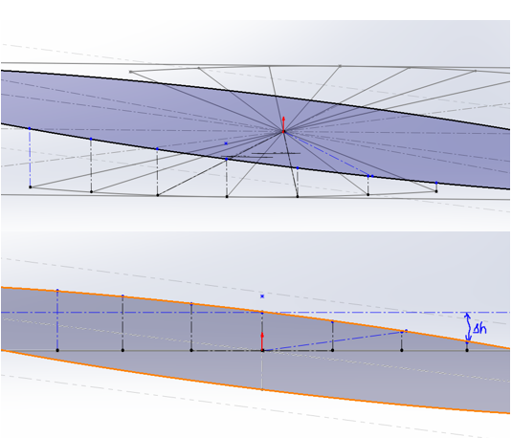
Figure: Camber Change Simulation
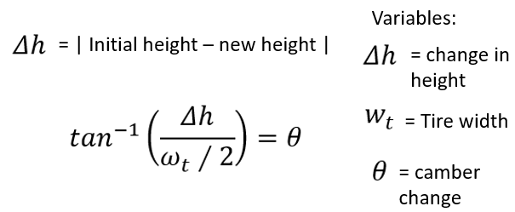
Figure 2: Camber equation
This was modeled using a 7 deg caster angle as well as a 7 deg KPI angle, which we expect to give us a good amount of camber change without being too high. Looking at this model in the side view, the image produces an ellipse which is an accurate representation of the amount of camber change depending on the steering angle. As you can see the change is not linear, however we do get a desired change in each direction to help supplement camber change during roll conditions.
The next set of calculations involves Free Body Diagrams as well as Force and Moment equations to start giving the team actual numbers to determine factors of safety for the parts they are designing. An example of this includes the Roll analysis and the forces that go into each suspension link as well as the pushrod system. This is shown in figure #() below.
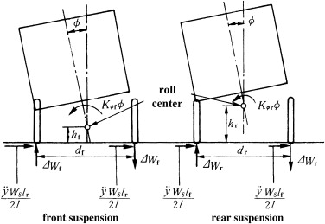
Figure 3: Roll Analysis
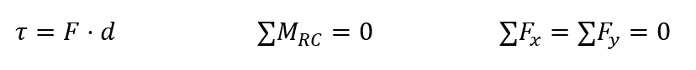
Figure 4: Force Analysis

As an outcome of this roll analysis done in the earlier 3.1.1 section, we can achieve a reaction force happening on the tire with the increased load. To do this, we used the sum of moments about the roll center and that of the reaction force on the tire at its distance from the centerline of the vehicle. We assumed worse case scenario to be full forces of roll bump and brake, which resulted of a reaction force of nearly 4000N vertically on the tire. This resulted in the calculations shown below.
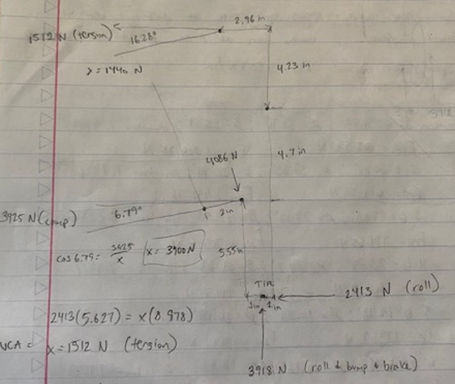
Figure 5: Hand Calculations

We can see that the lower control arm is in 4000N of compression, with a bending moment acting on the pushrod. The upper control arm is in 1500 N of tension. All these values were calculated by assuming some points were fixed in space, such as the lower and upper control arm pivot points on the left side. Analyzing each side one by one we were able to achieve these values.
From these reaction forces, we can then use the total pushrod axial force calculated to find our desired spring rate looking at our pushrod geometry. A matlab code was generated for this using simple geometry in the design, and analyzing different positions through its range of motion and taking the angles between different components to see how the forces transfer. From our rocker arms motion ratio of 1.4, we can find that the force applied to the spring at full travel is around 3100 N for 1.8 inches of travel, resulting in a spring rate of 500 Lbs/in. This seems reasonable since last year used 200 Lbs/in, they had a motion ratio of 1, and the suspension frequently bottomed out from more miniscule forces, causing the car to handle poorly in some situations.
Using excel, we can input our resulting pushrod and tire forces at different travel positions to find how much droop and bump our suspension will have. This is shown in the graph below.
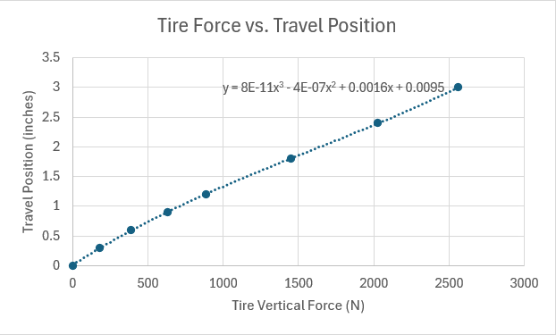
Figure 6: Travel position vs. Vertical tire force

Having a static load of 600 N to the wheel, we can easily find our ride height and our travel numbers from this data with a 500 Lbs/in spring rate.

Table 1: Travel position at ride height and full cornering forces
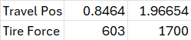

The above table shows results of ride height as well as full cornering in the vehicle. Conservative numbers were used in the calculations for tire force, so it may be likely we will need to choose a lower spring rate after the first round of testing. The left shows the vertical travel position at ride height (static) and the right shows the vertical travel position during 2gs of lateral acceleration. This spring rate allows for any possibility of a bump load happening during cornering, and with these numbers we are confident the vehicle will handle appropriately even in harsh conditions.

Brakes - Chris Laney
The primary modeling tools used to design the braking system are SolidWorks and Matlab. Matlab is an extremely useful tool in this context for the sake of iterative calculations as the design process progresses. SolidWorks is also extremely useful due to it’s ability to simulate forces, similar to Ansys, as well as it’s many useful modeling tools. Without these two tools, this aspect of the project would be very challenging.
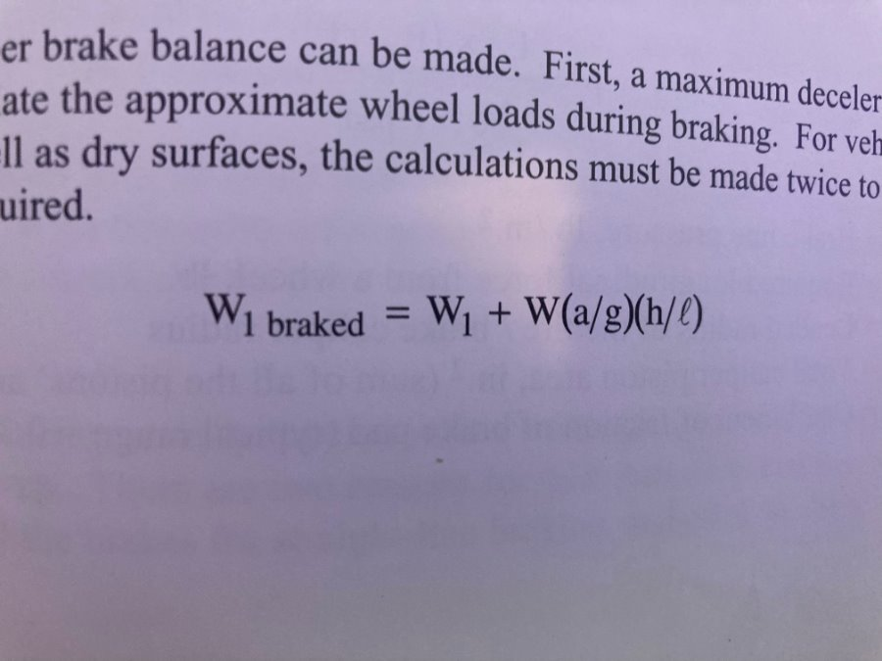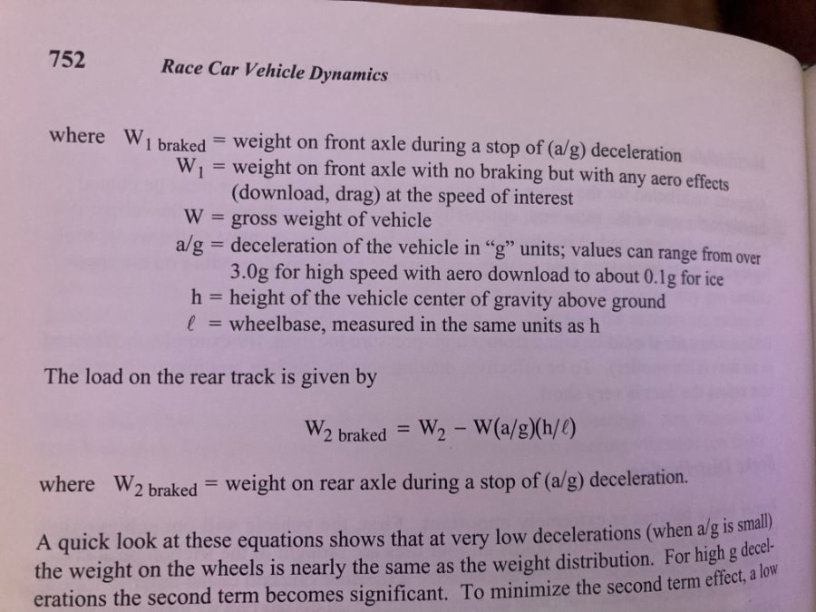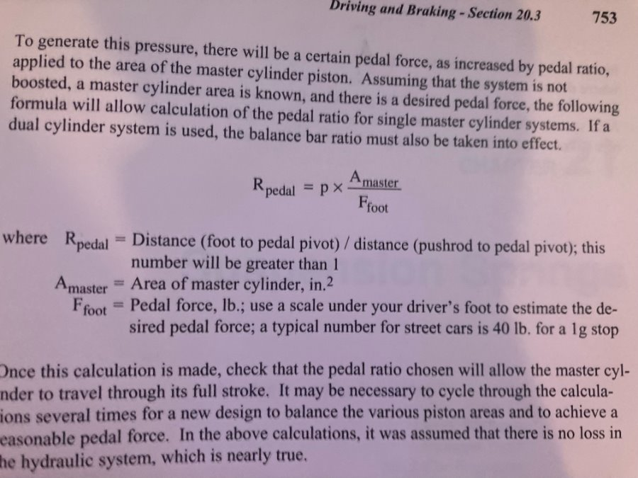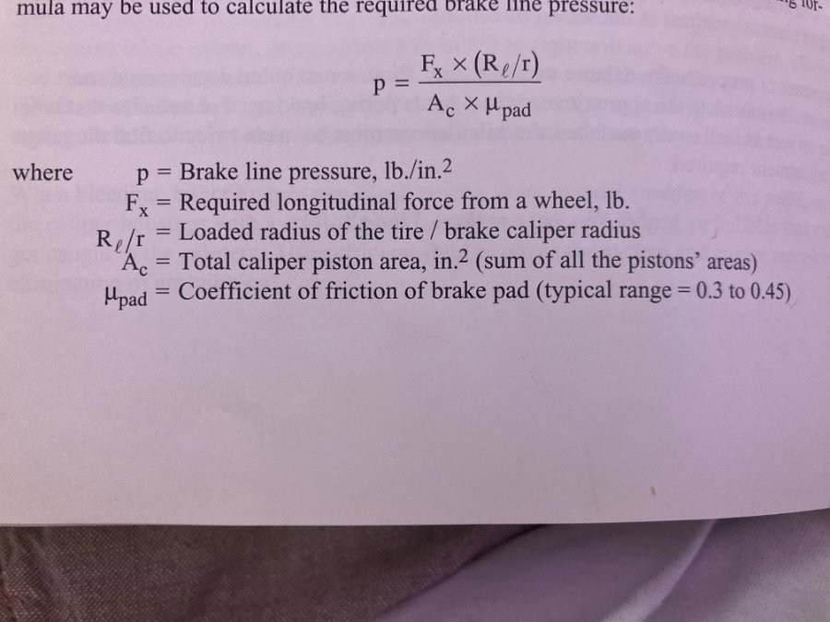
Figure 5: Braking Calculations from Race Car Vehicle Dynamics[4]
Race Car Vehicle Dynamics gives us a lot of applicable equations for our car’s braking performance. Above are the equations presented for dynamic wheel weights and internal brake line pressure, both of which directly affect the car’s maximum braking performance. Inputting these into Matlab, we get these results. More useful equations can be found in citations 2,5, and 7.
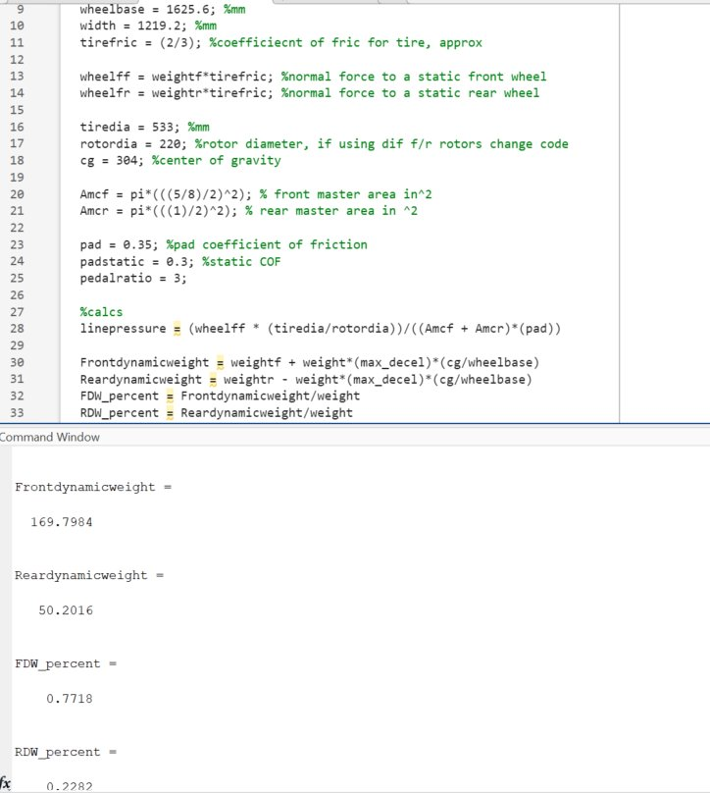
Figure 6: Matlab Code
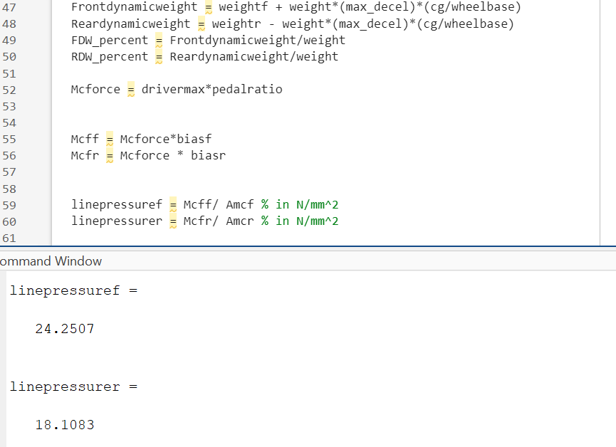
Figure 7: Matlab code and sample results
First picture showing dynamic weight balance in percentages and KG, second calculation showing brake line pressure at theoretical maximum driver load of 2000N in N/mm^2. 18 translates to about 2600 psi and 24 translates to 3770 psi, much more than the 750 required to lock up the tires. This iteration was done with a pedal ratio of 4 and master cylinder bores of 5/8 and 3/4” for front and rear respectively.
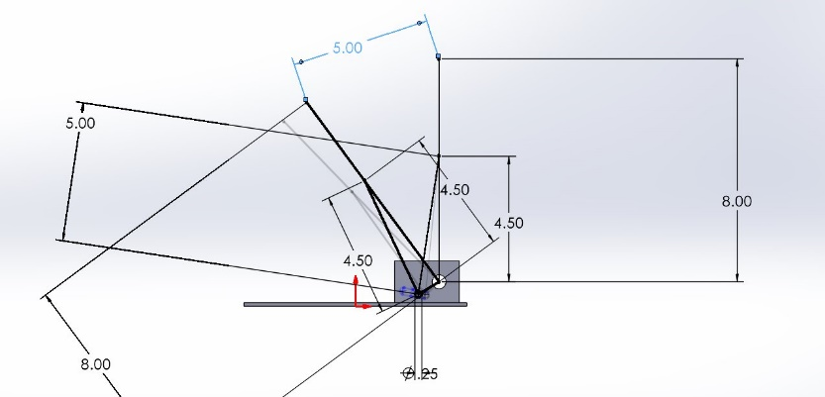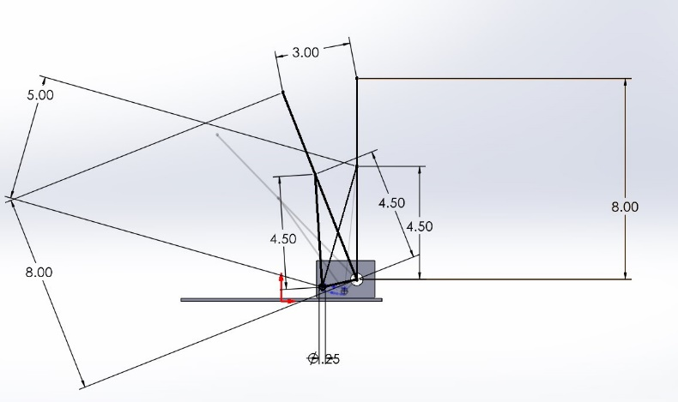
Figure 8: SolidWorks Pedal Ratio Iterations
This SolidWorks sketch represents the pedal in it’s fully uncompressed and fully compressed positions. The pedal ratio is represented at the top by the 5 and 3 respectively for top and bottom photos. Using different iterations of pedal ratio, I was able to sketch the curve needed for adjusting the pedal ratio whilst having a constant mounting location at the top of the pedal. From here, I designed a circular slot to be milled into the bottom mounting swivel for the master cylinders. This will most likely have to be a CNC part due to it’s geometry. The ratio range I aimed for in my design was about 2-7 so that there is a large range of adjustability for various conditions and driver preference.
To calculate the required force to lock up the brakes, there is a variety of approaches. For the sake of simplicity, the frictional force from the tires was initial input and from there brake line pressure and pedal input as a function of the pedal ratio. The pedal ratio is ratio of driver pedal input to force into the master cylinder. A higher value here means a greater force to the master cylinder and brake calipers, but also increased effort to move the pedal. Due to the number of variables effecting the driver’s input, the pedal box and pedal itself will have to be significantly overbuilt. This was all calculated utilizing Matlab, and it was discovered that it would be possible to adjust the pedals in such a way that the both the flexible and hard brake lines could burst with enough driver input. The force required to lock up the brakes was 391 N/m, or about 750 PSI with the corresponding pad coefficient of friction and surface area.
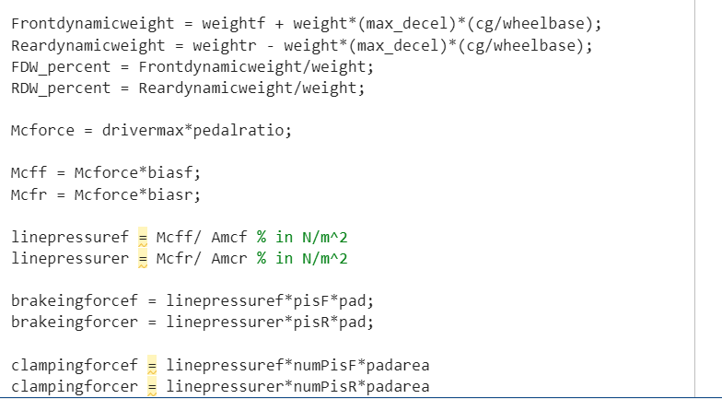

A-Arm Garrett Pearson
A crucial aspect of A-arm design is the length of the arm. The length of an A-arm is defined as the length from the wheel hub to the mounting point on the body. This length effects, camber, suspension travel, and overall handling, all key components in the performance of a race car.
To find how arm length effects camber I used the “VSup” suspension geometry program. I input our suspension measurements to map out the exact layout our car will have. Using the graphing function, I was able to show the relationship between Arm length and Camber Angle.
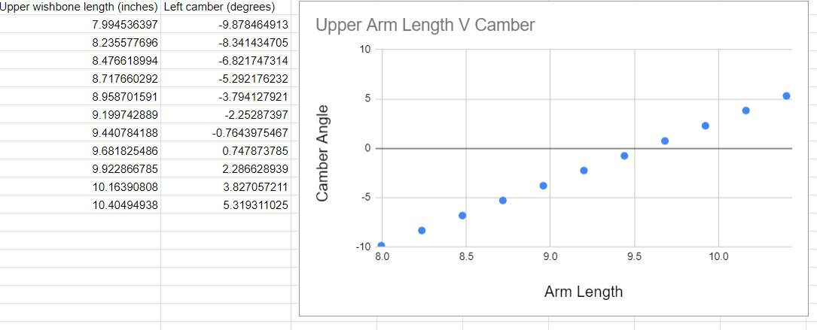Figure 9: Arm length vs camber
To achieve a desired camber angle of -1 degree, the graph shows that our arm length should be around 9.5 in. Now that we have found our ideal arm length, we must find out how that length affects the instant center of the vehicle.
The instant center is the point at which the car rotates around and is key to understanding how the car will corner. A high instant center means the car will tend to have a slower steering response time, while a lower instant center gives us faster steering response time more ideal for track racing.
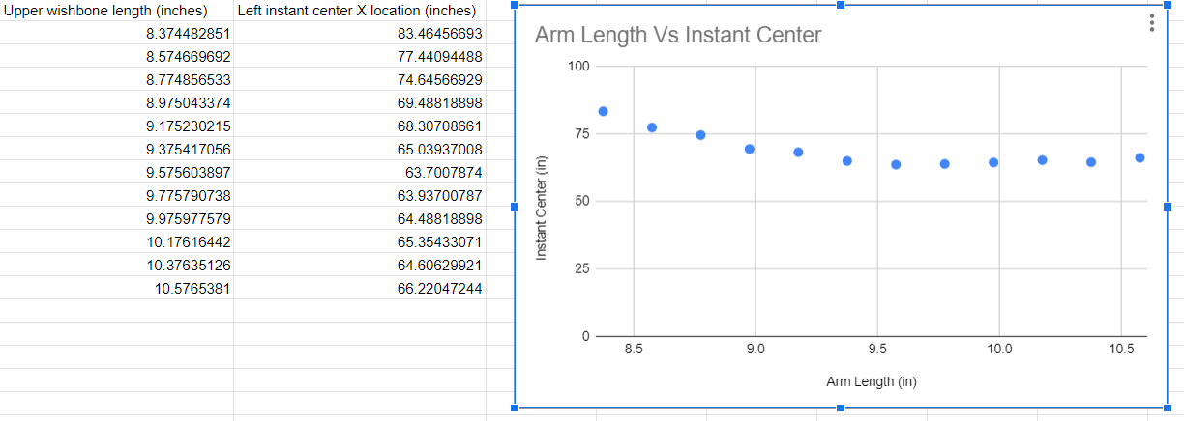 Figure 10: Arm length vs instant center
Using the same ”VSusp” program we can graph how our arm length affects the instant center. Our chosen arm length of 9.5 in gives us an instant center of about 64 in. This is a relatively low instant center, which is ideal. As the arm becomes very long or very short the instant center grows very large, which is not ideal for our car.
3.3.4 Mathew Cusson
The first variable that had to be accounted for in the steering wheel design are the materials used. This is accomplished by using ideal measurements for our steering column material and tie rod material. The governing equation needed is the following, where stress is equal to the force over the given area.

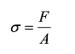
Figure 11: Stress equation
Along with this calculation we know that the following equation for shear stress is shown, where T is the torque, C is the radius from the center of the object rotating to the point where the force is acting. J is the polar moment of inertia and is relevant to the material being used. In this instance the steering column is a solid rod.

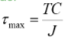
Figure 12: Shear stress equation
The goal for the equations was to find the needed radius of the steering column and the factor of safety for the tie rods. The minimum value wanted is five for maximized safety and durability of the part. For the steering column the yield strength of 40000 PSI is used from 6061 aluminum assuming a torque of 100 Ft*Lbs which is the max amount that should be expected under worst case scenario use. We adjust this equation to isolate the diameter of the function which leads to the following equation:

(pi* d^3)/16 = 1200in/lb / 8000 lb/in2

Solving this we see a minimum diameter of .914 in or a minimum radius of .457 in which is acceptable since the minimum diameter of the steering column that was being considered for the design is .6 in.
For the tie rod there is going to be 1024 steel used with a yield stress of 50800 PSI and after applying a factor of safety of five the max stress is 10160 PSI. using the above equation for stress the formula is arranged for force in Lb and the equation is as follows:

F = 10160lb/in2 / (* (.0049 in 2))

Where .0049 in is the difference in the outer radius from the inner radius. Solving for this means a max force of 156.41 Lb. This value is a reasonably high value for the kind of force that can be seen in the tube of the tie rod.

The next calculated part of the vehicle dynamics is the bump steer calculation which is derived as a three-dimensional effect that is derived from a model of the vehicle where the measurement in the steering angle is taken at bump and droop to determine the angle. This value is kept to a minimum to ensure predictable driving feel for the driver and overall stability of the vehicle.

The vehicle suspension is shown below where the circle represents the wheel radius at any given point throughout a turn at the location height of the tie rod.
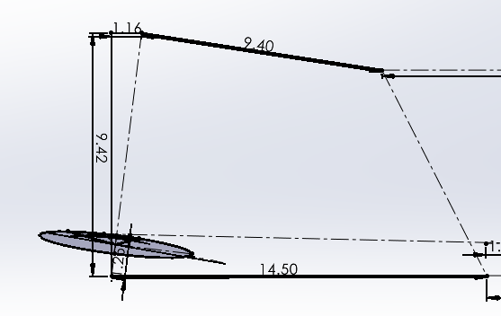
Figure 13: Suspension arm

The current expected values for this steering rack setup is .48 in at bump and .16 in at droop which are both values within reason and when comparing this steering rack size to a longer model the new bump and droop values are .2 in at bump and .11 at droop. This is a consideration to use a new steering rack but may infringe on the space limits that the vehicle has.

Through additional research the value from last year’s car was tested and analyzed for the force required to turn the wheel. This particular measurement was important due to multiple complaints of the vehicle being hard to drive due to excessive force needed to turn the wheel in any direction. The value found from testing showed a 50 lb force required to turn the wheel and with the steering wheel having a radius of 4 in there is a torque of 12.5 ft lb through the steering rack. With unit conversions being done in the system the torque through the steering rack is 2260 N cm. With the radius of the steering pinion being 2 cm the total force into the tie rods are 1130 N of force. As a safety factor being used the maximum force will be doubled to 100 lb to ensure that the parts are designed with a high factor of safety for operational use, which makes the total forces seen 25 ft lb and 2260 N.

3.3.5 Pushrod assembly- Joseph Ciao
For the pushrod assembly design, one critical aspect is calculating the buckling load to ensure the pushrod can withstand the forces acting upon it. This is done using the Euler buckling equation:

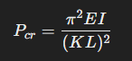
Figure 14: Euler buckling equation

where P_{cr} is the critical buckling load, Eis the modulus of elasticity, I is the moment of inertia of the pushrod cross-section, K is the column effective length factor, and L is the length of the pushrod. This equation guides the selection of appropriate length and thickness for the pushrod to prevent buckling under compression. Once the suspension geometry is finalized, we can determine the exact length of the pushrod and verify its structural integrity. Finite element analysis (FEA) will be performed using ANSYS to simulate and stress-test the pushrod and rocker arm. This analysis will ensure the components meet the required strength and stiffness under operational loads, allowing us to fine-tune the dimensions.
Our goal for this year is to streamline the design process by simplifying the geometry of the rocker armwhile maintaining structural robustness.

The rocker arm design will target a close-to-1:1 ratio in terms of motion transmission, with the suspension system aiming for a 1.5:1 motion ratio to balance performance and control. Simplifying the design reduces manufacturing time and cost without compromising the system’s effectiveness.

Design Concepts

Functional Decomposition
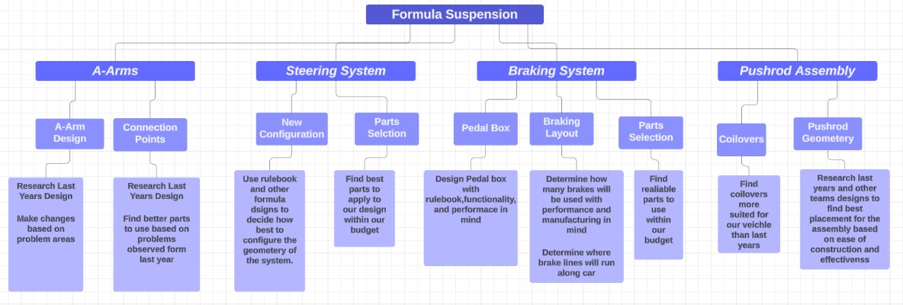
Figure 16: Suspension Functional Decomposition

Our Decomposition chart breaks down the individual systems that come together to make our vehicle suspension. Each sub-section has several main issues that need to be resolved for our vehicle to perform well. Underneath each issue are the key things to investigate that will help create an effective solution.

Concept Generation

Steering Knuckles (Parker Johnson)
There were a few designs to be considered during the generation process, the most notable being the simple knuckle design (Design 1) and the more complex steel design (Design 3). There is another more complicated aluminum design (Design 2) that is also evaluated below.
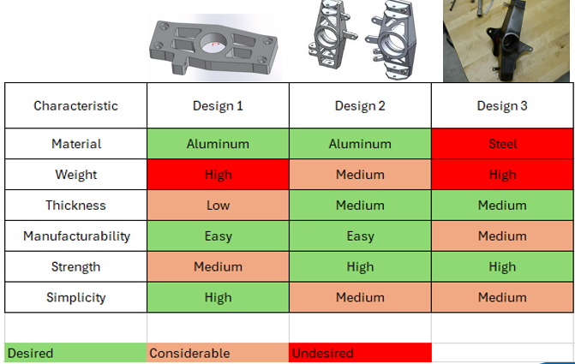
Figure 17: Knuckle Concept Generation

This process gave us valuable insight and a way to quantify desired qualities of each design. As we can see from the table above, design 2 stood out the most as far as manufacturability, material and strength being the most important qualities in this decision process. Further analysis is done later in the concept selection section.

Brakes Assembly (Chris Laney)
Most important braking parts are to be purchased. Rotors, calipers, master cylinders and pedal box orientation are the significant subsystems that needed further analysis. Pad choice is dependent on rotor material, and since these material properties vary significantly, the master cylinder bore, which impacts the force coming out of the master cylinder, is also a variable. Securely mounting all these parts is also a significant concern, as wheel hubs, knuckle geometry, and pedal box geometry area are all a function of other the other sub-teams and subsystems within the sub-team. Approaching designing all of these aspects is a changing game so there is a large variety of designs present for each sub-system.
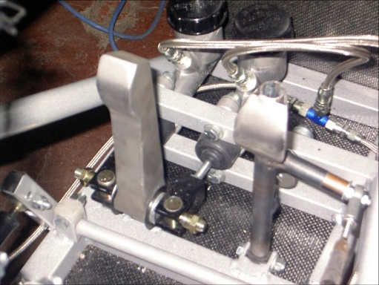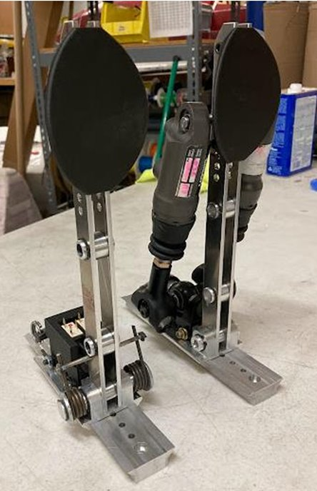
Figure 19: Example Pedal Box designs

These two images represent the two rough pedal box designs, the left picture being the traditional flange-mount master cylinder and the right picture utilizing swivel mounted master cylinders. Some pros of the flange-mount style is that it’s simple, easy to reinforce, easy to manufacture/build, and linear in terms of pedal travel and pedal ratio. Some cons involve it being heavy and bulky. Some pros of the swivel master cylinder design include lack of weight, adjustability, and small volume. Some cons of the swivel master cylinder design include it’s relative difficulty in manufacturing, as welding is required, and the cost of the master cylinders themselves.
With respect to the rotor/pad/caliper assembly, the standout combination from the benchmarking done was the Wilwood GP200 caliper with varying rotor compounds and one of two pads depending on the rotor material. This caliper seems like the go-to for many teams and it’s reliability and simplicity trump most of the shelf calipers of this size and weight. Many off the shelf rotors are available in varying sizes, compounds, and designs at a reasonably affordable price. Due to the use of Miata wheel hubs, there is essentially no off the shelf options out there in our desired diameter so the decision had to be made to make them in house.
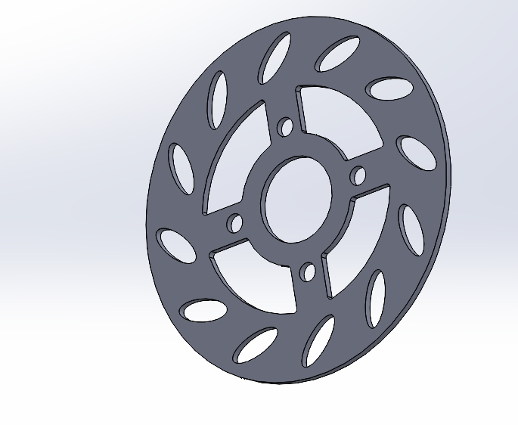
This brake rotor was designed with cooling and weight-saving in mind. Additionally, it’s two-dimensional geometry makes it easy work of the water jet.

Steering Assembly – Matthew Cusson
The steering assembly of the vehicle is made of four primary components that are the steering wheel, steering column, steering rack, and tie rods. Each of these parts of the assembly has multiple variations and each is evaluated by their cost, simplicity, weight, and durability. The first category being evaluated is the steering wheel with the matrix shown below.
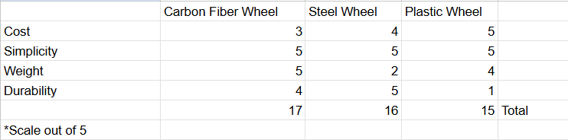
This shows that the carbon fiber steering wheel is the most optimal choice as even though it features the highest cost it is also the lightest weight and very durable at this weight which makes it easy to use.

The next category to be evaluated is the steering column which has the choice between an aluminum column, steel column, or a carbon fiber column.
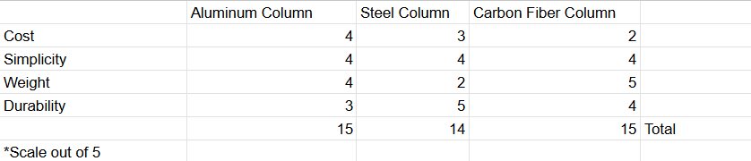
This decision comes down to the cost as the carbon fiber steering column is a popular choice for more established teams for the rigidity and a weight reduction that it can offer. The aluminum column is not quite as effective but is much more cost effective and strong when constructed properly. The next category is the steering rack and is a decision between a rack and pinion design or recirulating ball. For the practical intents of this project the rack and pinion will be the one used as it has been the standard established by most of the FSAE teams to great success due to the simplicity and efficiency that it produces. For the final category the tie rods will be decided between hollow tie rods and solid tie rods.
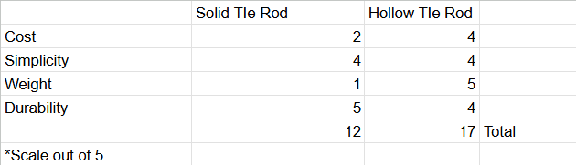
The hollow tie rod is a much better alternative as it has immense weight saving over a solid tie rod and loses minimal durability in comparison. As a whole the designs that work the best are lightweight and simple that prioritize a lower cost for their use. The final category to do an evaluation of is the column connecting material which sees the option of a u-joint, double u joint, or mil-spec joint.
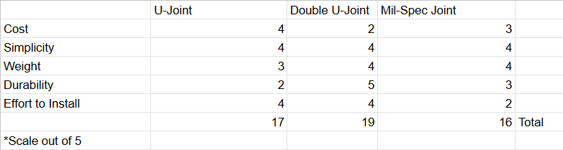
The single u-joint system is not enough on its own and sees multiple issues with angles due to the high angle needed to meet the steering rack. The Mil-Spec joint was initially seen to be a good choice but suffers from a difficult instillation process as it requires welding to the column which causes issues with replacement should it be required later in the design.

Rocker arm Design (Joseph)
The Rocker Arm has gone through 2 main integrations. The first iteration focused on seeing how far weight saving could be pushed and see what areas needed to be reinforced. The second design took a more conservative approach using the Ansys information collected for the design changes. The final version was made to further improve weight reduction and strengthen the points that showed the highest stress points through ansys.
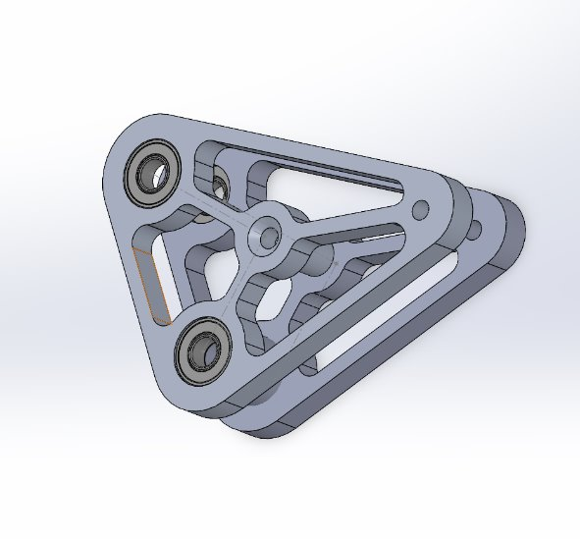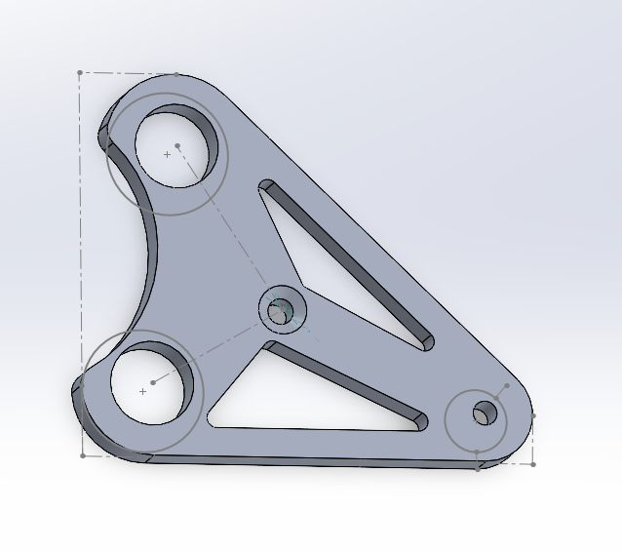

Figure Rocker arm version one Figure rocker arm version 2
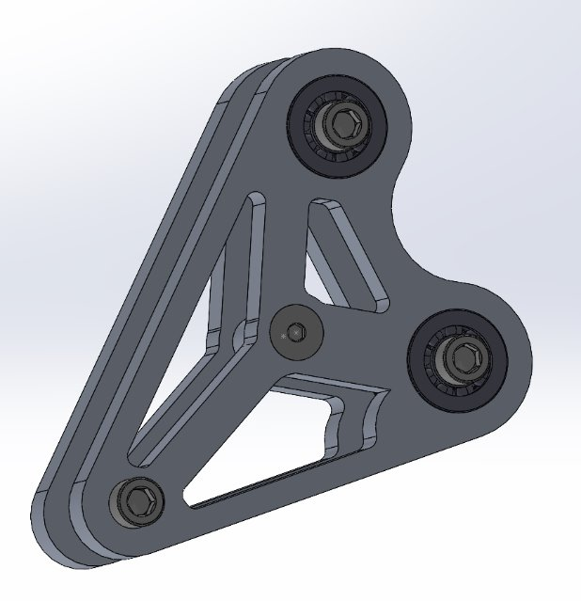
Figure Final front Rocker design Cad

For the rear rocker arm the design took the lessons learned from weight optimization of the front rocker arms as well as the knuckle design. The rear was made slightly thicker and using a truss like design for the weight optimization. Shown below is the final design after being water machined
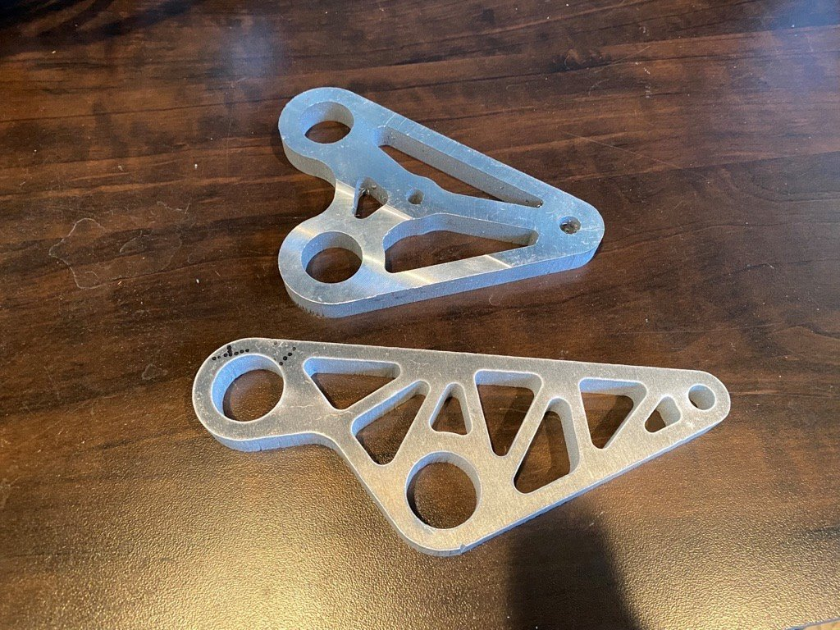Final Rear Rocker design

Selection Criteria

Steering Knuckles (Parker Johnson)
The selection criteria defined for the steering knuckles were largely based of manufacturability, since our team will be very limited on the ability to create complex features on our parts. We are mainly limited to outsourcing any work we have, besides anything that can be done on the vertical mill of lathe. The next most important selection criteria is the material itself, since aluminum is easily machinable and can be made as one piece. The final and most important criteria is the strength of the component, which is mainly affected by the design. There are many forces acting on this member that cause tension, compression and bending moments about different points, and this component is crucial to holding the wheels together on the car.

Brakes Assembly – Chris Laney
Between the two pedal box designs, a decision matrix was not required as the decision was relatively simple. The standout qualities of the design that took part in the decision making process was weight, adjustability, and size. For the caliper/pad/rotor designs, a decision matrix is required to make an informed decision. The largest variable at play here is the rotor material, qualities of which we care about are price, weight, thermal conductivity, coefficient of friction, machinability, and overall strength.

Steering Assembly – Matthew Cusson
The options are weighed against each other by way of weight, cost, and ability to obtain the materials within a short time frame. These metrics all exist to satisfy the requirements for FSAE 2024 vehicle requirements for steering assemblies that specify the following: There is at most 7 degrees of play in the steering wheel. The steering rack must be mechanically connected to the wheels. The steering rack must be mechanically attached to the chassis. All steering joints must be visible. The steering column must be connected with a quick disconnect steering wheel. The steering wheel needs an oval or near oval perimeter. The steering wheel must stay below the front hoop of the vehicle.

Pushrod Assembly – Joseph Ciao
Due to the limited time the team will have access to the CNC machine the design choice was made largely to ease manufacturing by having the design be able to be mostly water jetted. The design needs to be able to mostly water jetted with final alterations being able to be completed using the NAU machine shop mill and lathe.

Concept Selection

Steering Knuckles (Parker Johnson)
The figure below shows the decision matrix created for the steering knuckles. It is apparent that the manufacturability, strength, and simplicity are of the highest importance, since they are the most important factors that will decide our success for the timeline our team has current and intends to follow. These are shown in the figure #(20) below.
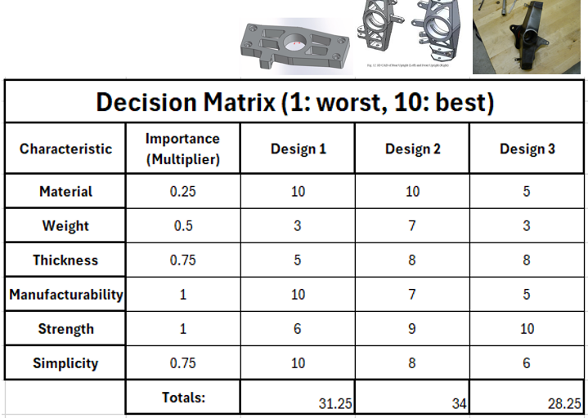
Table 3: Steering Knuckle Decision Matrix

Based off this analysis, we can see that Design 2 is rated the highest for multiple reasons. Most of these points have already been discussed previously in the report but is also worth mentioning that design 2 will look good, perform well under different stresses, and be able to support a wide range of wheel hub styles. Design 3 is rated the lowest since it is steel, which will increase the weight, and is also made of many pieces that will be required to be welded together. This design does not fit well with our timeline and therefore will be avoided. Design 1 is simple and may be easy to make, however it does not look that appealing and will not perform well under bending stresses. After each consideration we found that Design 2 is best. Preliminary design iterations have already been done and are shown below in figure #(21).
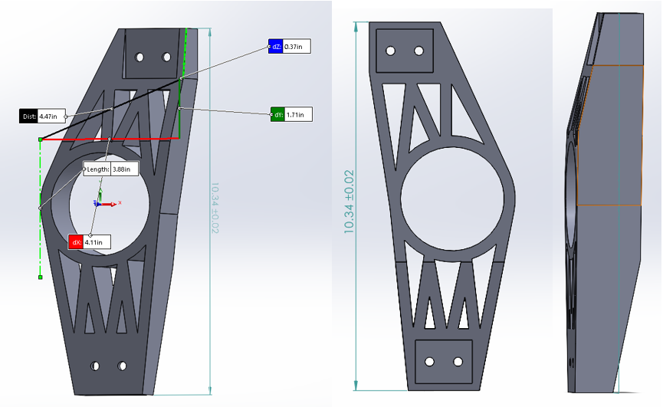
Figure 20: Steering Knuckle Rough CAD

Brakes Assembly (Chris Laney)
The decision for the pedal box design was straightforward. Due to the potential simplicity of the rest of the system, this subsystem was worthwhile to put more time into, so it was decided early on to proceed with a swivel master cylinder design due to its lightweight design, compact packaging, and adjustability potential.
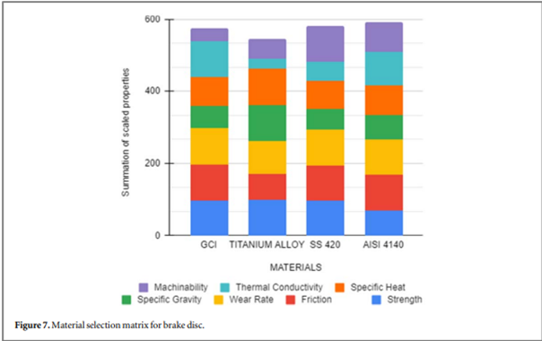
Figure 21: Decision Matrix for rotor selection
A very similar decision to ours was made by the MIT team [back in 2018, and as their decision matrix had matching parameters to ours minus the cost aspect]. The price of GCI is significantly less than that of aluminum alloys, titanium alloys, or common compounds of stainless steel in the desired sizes, however finding sheet GCI so that we can utilize the water jet is a challenge. Since rotors are a wear item and will undergo more design changes later it is a significant concern to be able to get/make more rotors in a short period. Titanium and various steels are the most available, however they are also the most expensive. 4130 is a close alternative to 4140, and is much cheaper and also quite available. 4130 is another common (not particularly exotic) material used by FSAE teams. From this ease of availability, machinability, cost, conductivity, and durability that exceed the requirements presented by our application 4130 was selected as the rotor material.

Steering Assembly (Matthew Cusson)
After evaluating the team budget and the expected forces that the parts will see the best alternatives have been selected for the vehicle. This design entails a system mounted below the legs with an aluminum steering column due to weight and price. After this are hollow tie rods with rod ends that are purchased because of the weight savings and simplicity to implement compared to a full rod. A double u joint will be used to connect the two halves of the steering rack because it is a constant velocity type joint that makes sure that the steering has no unexpected variation in rotation speed when turning the wheel. This system will be mounted to the chassis using a pillow bearing mount due to the play that is minimized by not having a rotating eye bolt. The final consideration used is that the steering wheel is going to be made from carbon fiber because the natural stiffness along with being lightweight allows it to be an ideal candidate for installing a shifting system into.

Pushrod Assembly
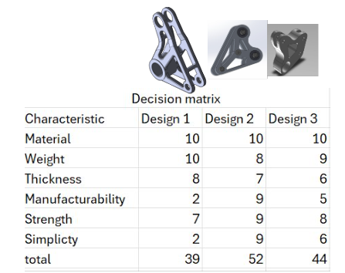
With manufacturing being by far the most important factor the design choice was very clear for the rocker arms. The other designs would need extension time with the CNC machine, which was not an option. The choice was to keep the simplest design and try to maximize its weight reduction possibilities. This design needed to be able to be completed over a number of short weekends with the water jetting facility. The spacer design was changed to make “washers’ separate from the rest of the spacer to heavily reduce manufacturing time.

Schedule and Budget

Schedule (Parker)
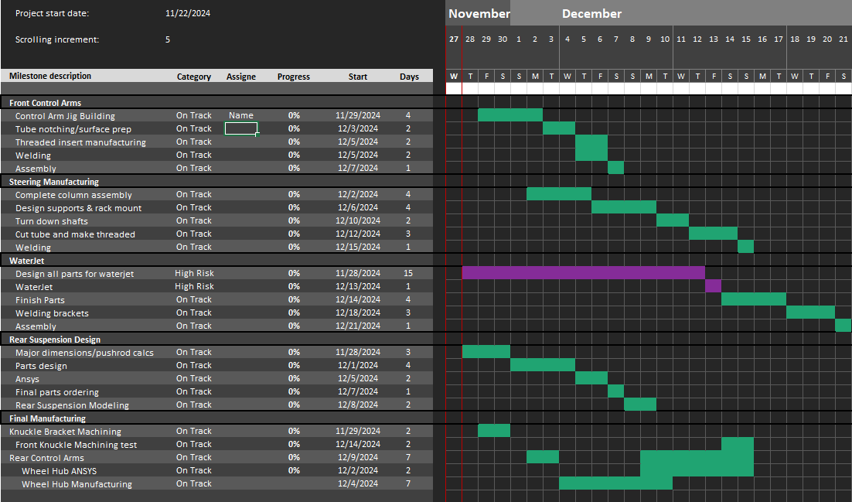
This schedule is a fairly accurate assessment of the timeline for the next couple months. This mainly includes manufacturing but doesn’t account for any unforeseen problems during manufacturing or the holidays. To predict an ending time for the suspension to be built, we are looking at the end of January for the suspension system to be complete.

Budget (Parker)
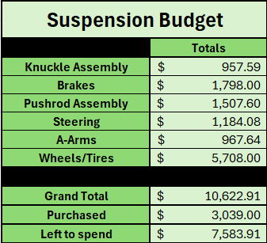

To combine all elements for the bill of materials in the next section, we have come up with a more updated budget for suspension. Since a parts list has been collected with a finite price range for different levels of quality, we are left with a decision to make over the quality of parts we want and the price we are willing to spend. The totals for each sub section of suspension are shown in the table above.

Bill of Materials (Chris)
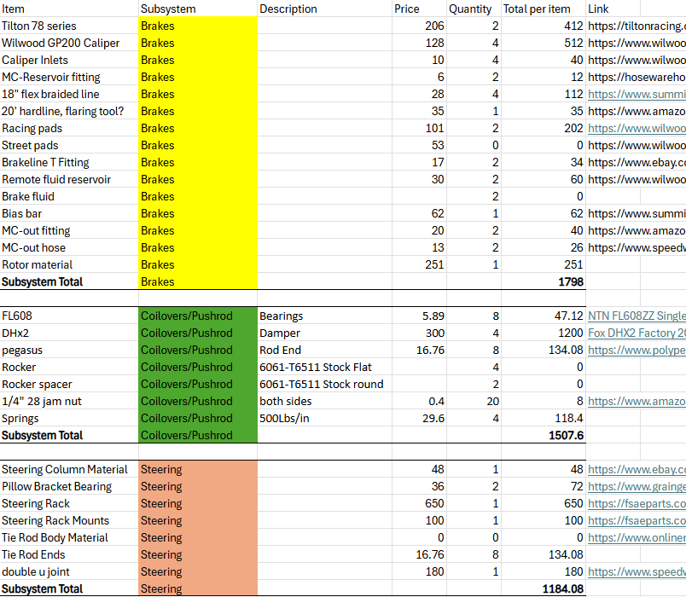
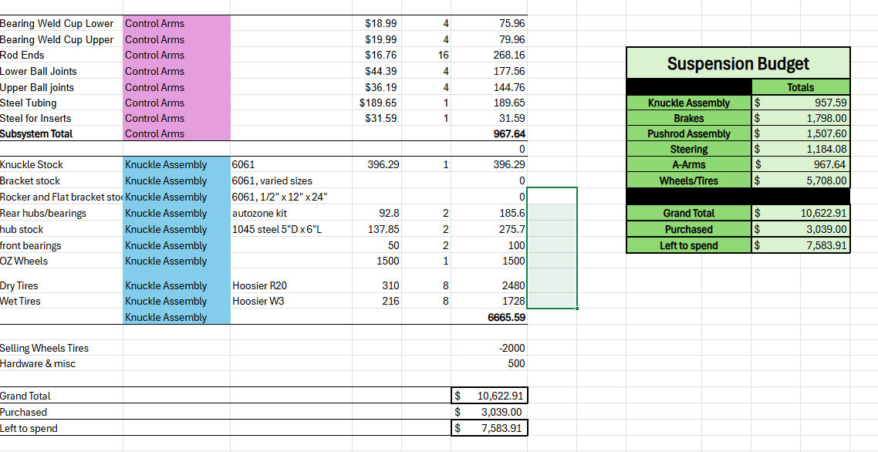
During the collection of all parts needed for the suspension system we can see that there were some unforeseen costs that added to our original budget. These mainly included tax and shipping for different parts. This provided us with a total budget and cost of $10,622, with $3,039 of that already purchased.

Design Validation and Initial Prototyping

6.1 Failure Modes and Effects Analysis (FMEA)
To ensure the safety and structural integrity of the vehicle's suspension system, we utilized Ansys to analyze its response to extreme forces. Key components, including control arms, wheel hubs, brake brackets, steering rods, and rocker arms, were individually tested to identify potential weak points in the designs. The applied forces were determined through calculations simulating worst-case scenarios. Using Ansys, we evaluated the safety factor for each component under maximum anticipated loads. Any part with a safety factor below 1 was redesigned to meet the required safety standards. Notable modifications included reinforcing the steering rods and increasing the thickness of supports in the brake brackets. These adjustments slightly increased the vehicle's weight, however their impact on overall performance is expected to be minimal, while significantly enhancing the vehicle's durability and structural strength.

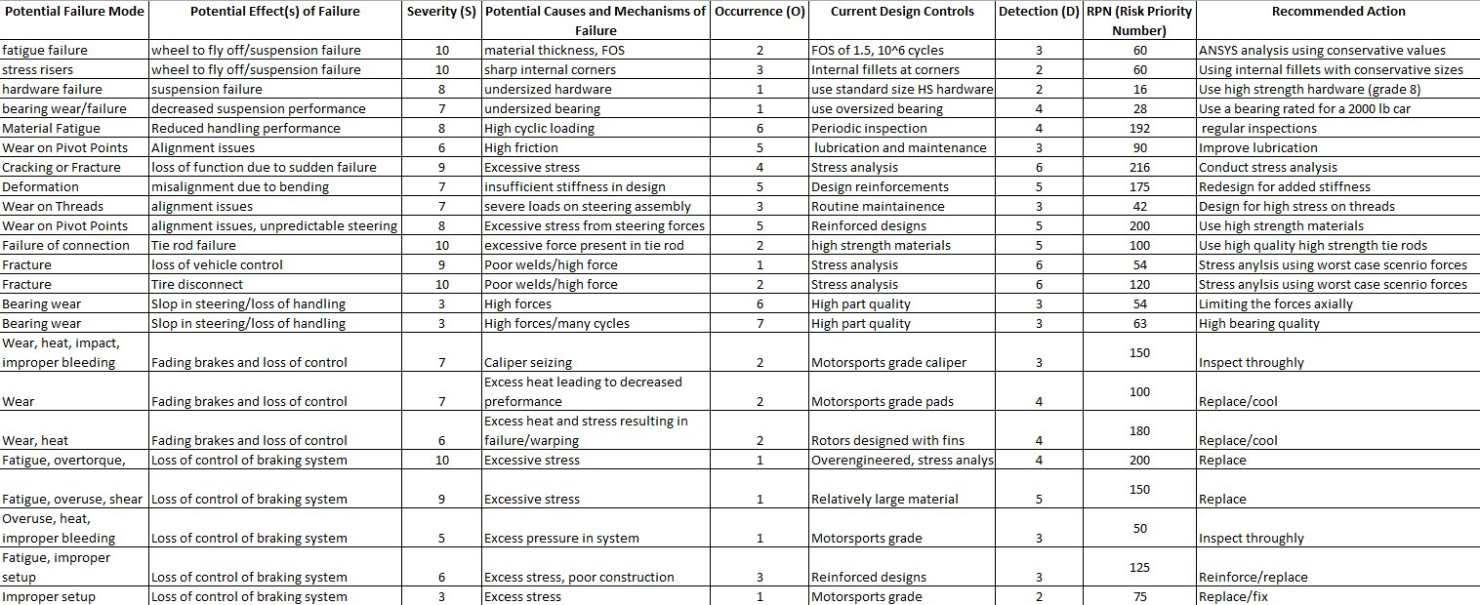

Figure Safety factor of Pushrod

6.1.1: Pushrod Assembly (Joseph)
The main component for failure is the connection points of the the two sides of the rocker arm. The connection points will use hardware that can handle much higher loads than expected. Weight saving is a big concern for the rocker arm as it will directly affect the performance of the pushrod assembly. The rocker arm is designed to ease manufacturing so more weight saving can come from bigger cutouts in the design. The pushrod can handle the expected forces with a good margin but if needed we could reduce its overall length if the design allows or make the rod thicker.
6.1.2: Brakes Assembly (Chris)
The main components in the braking system that are at risk of failure in a high-stress/load situation is the brake rotors and brake pedal box assembly. Both of these parts are to be overbuilt to accommodate the large variety of forces due to the large adjustability of this system. Weight saving is a concern in the pedal box, but as the brake rotors themselves aren’t all that heavy to begin with, it is safe and a good idea to thicken these parts to avoid failure, increase performance, and increase life. In this case, it was a no-brainer to overbuild the rotors in terms of thickness and a thickness of 5/32” was selected.
The pedal box is designed with significant adjustability in mind. For this reason, the decision was made to individually mount each of the pedals. The brake pedal is to be mounted with double the provisions as the gas/clutch pedals due to its more frequent use and higher stress involved. Additionally, custom brackets were manufactured to reduce binding and increase strength.

6.1.3 Steering Knuckles (Parker)
The main failure modes of the steering knuckles are the material itself not being thick enough or made of a strong enough material. Some other factors include of not having big or strong enough hardware to support the loads in each location. Some potential failures of the system include of the whole suspension falling apart, which is obviously not ideal given it would cause the driver to lose control and would be very dangerous.

These potential failure points are mitigated by increasing the fillet size in some locations as well as making high stress members thicker. We can also do an in depth ANSYS analysis to locate potential failure points on the steering knuckle and redesign accordingly.

6.1.4 Steering System (Matthew)
The main forces that are at play are similar to the A-Arms in terms of failure where an excess force can cause the tie rods to deform or the steering column to see similar effects. This includes shearing of the rods, failure of the threads, or loss of control due to the mounting surfaces being broken due to the forces seen.

These concerns were mitigated with strong steel tie rod tubes with thick tie rod ends that have been carefully welded as well as rod ends that are significantly higher quality than last year as well as designing the steering column and mounting brackets to survive at two times the expected worst case scenario force.

6.2 Initial Prototyping
6.2.1 Rocker Arm/Pushrod (Joseph)
Changes were made from the first version of the rocker arm to allow clearance for the travel of the damper at full up travel while maintaining the needed structural integrity to handle the forces and maintain a 1.5 safety factor. Analysis using the calculated forces was done using Ansys on the new design was performed to show deformation, life cycles, and safety factor. From here material optimization can be done on areas shown to not be under a high level of stress with the risk being this could compromise the part so testing needs to continue of every interaction.
Version 2 of the rocker arm was done in SolidWorks with an assembly on the damper selection to model for the needed Clearnce at 40 degrees. The thickness of each rocker was increased from .4 inches to .44 inches to house the bearing selection. The edge walls were increased from .2 in to .3 to maintain structural integrity after the clearance changes were made. The spacers were increased from .67 in to .85 to allow room to mount the damper. The results showed that only the filler parts meant to simulate the hardware were under the needed safety factor. At this point we now have a working design that could be used in the car and meets the needed requirements. For the pushrod to simplify manufacturing and logistics. Testing with Ansys was done using the same materials and for the a-arms. Under the load calculated the pushrod had a minimum safety factor of 1.367 which meets the requirements.

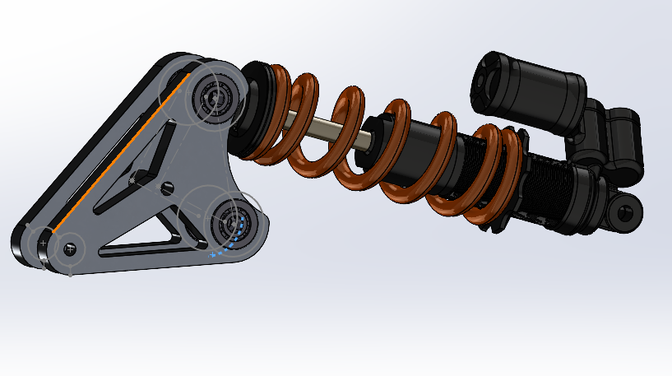Figure .Version two of rocker arm with damper

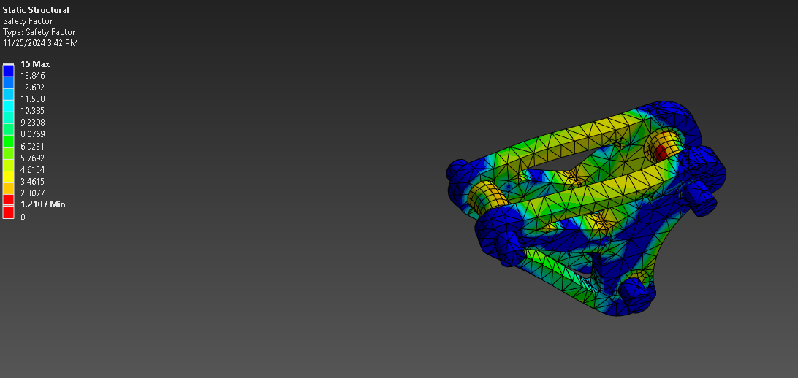
Figure safety factor of rocker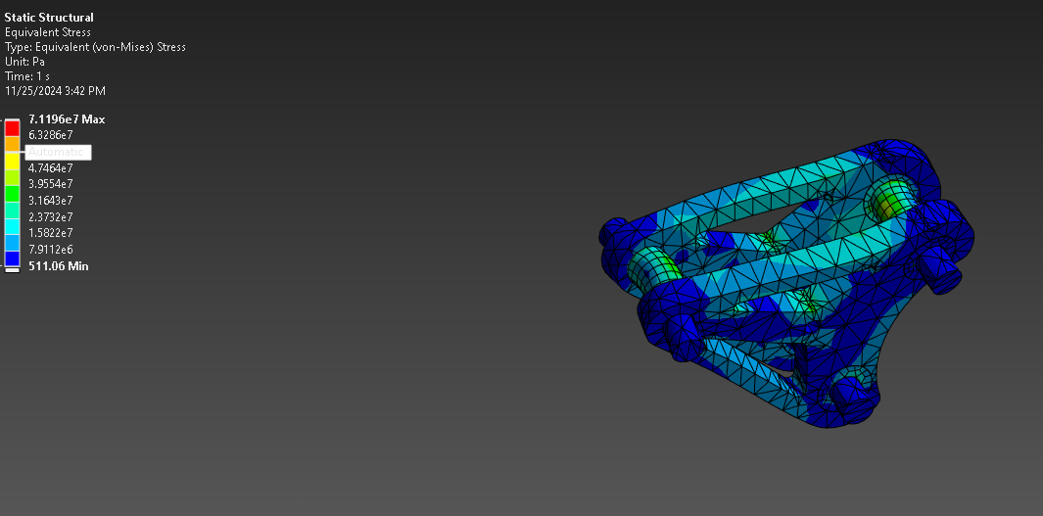
Figure Stress of rocker arm

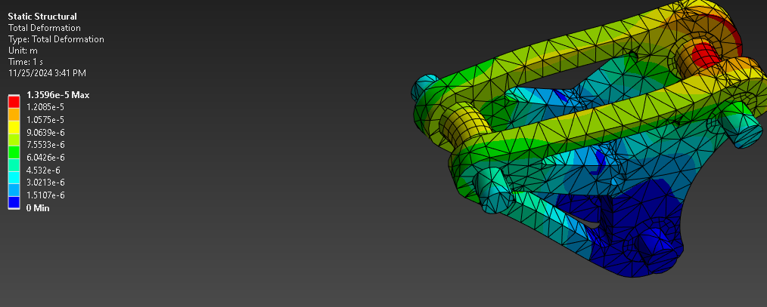
Figure Deformation of Rocker arm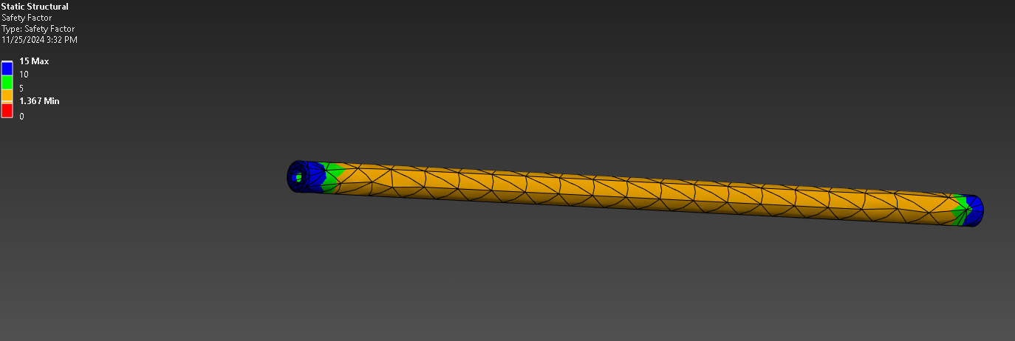
6.2.2 Brakes Assembly (Chris)
Mounting the brake caliper securely is a major safety concern. Should this part fail, many other parts in the braking system would be damaged, not to mention the car and driver if an accident is inevitable. The major limiting factor of loads on this member is the force provided by the tires against the momentum of the car; at a certain point the tires can no longer slow the weight of the car at the same pace that the brakes can, and the tires lock up and stop rotating. Due to this fact, the force that this component may see is exactly half of the loads presented in this analysis. Through eight ANSYS and SolidWorks iterations, I have come to a brake caliper design that I’m confident in, where the factor of safety for double the expected loading is about 1.5. Some examples of changes made during these iterations are changing around sizes of fillets, internal members, external members, and bolt holes. The variables that seemed to improve the strength of the bracket the most are increasing the size of internal members and internal fillets.
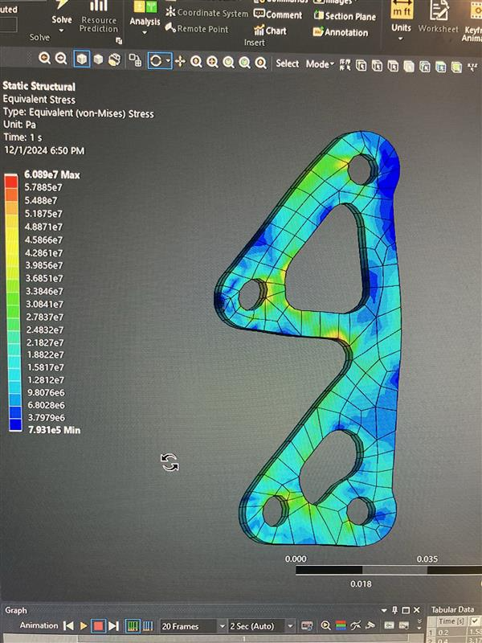
Figure Brake Caliper CAD + ANSYS analysis
Through more careful analysis and consideration, a new concept was designed without the member between the caliper bolts due to it already being fixed. A similar design was made for the rear brackets, as shown below.
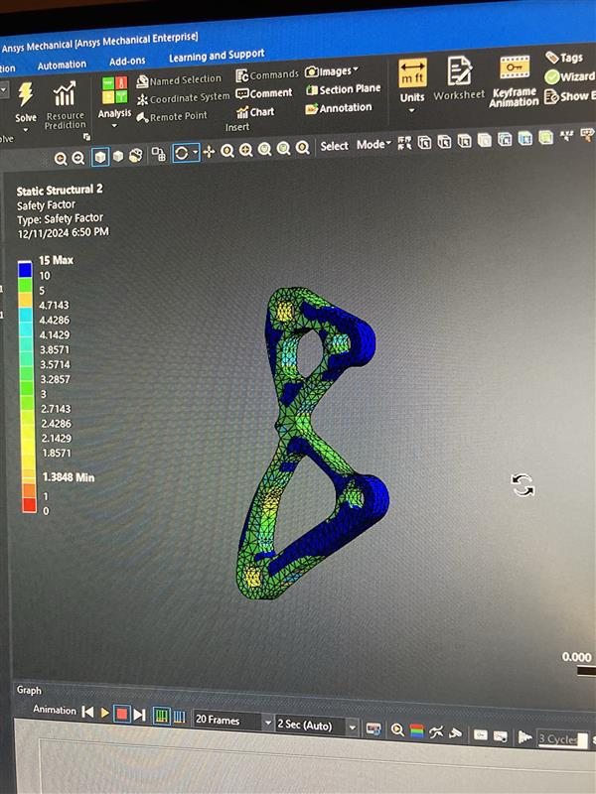
Another analysis preformed was with the brake caliper attached in the analysis, from this experiment the team learned that it’s best to keep ANSYS mechanical analyses relatively simple for computing time’s sake and ease of adjustment.
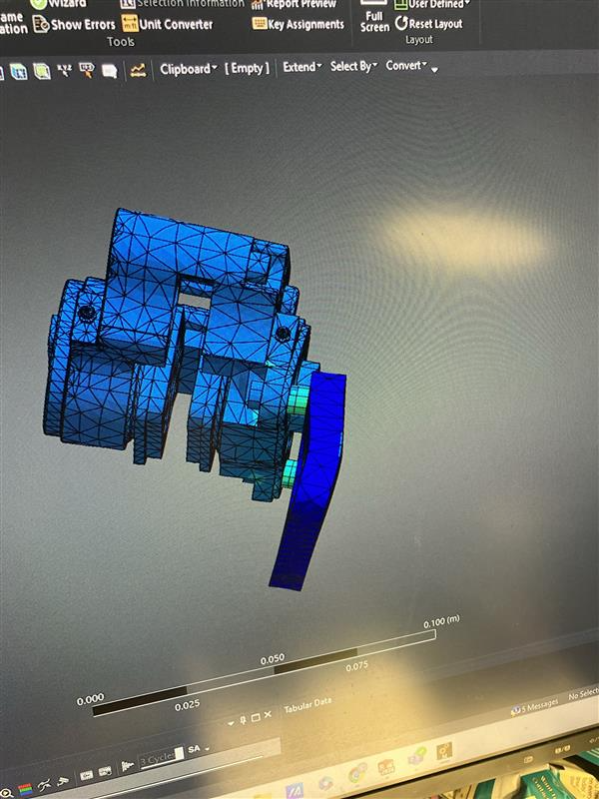
The design of the brake rotors was a long and in-depth process of changing analyses and iterating on designs. Through about 10 versions, a final rotor was decided upon for it’s strength in all sorts of analyses. Shown below is the final iteration, along with a few rotor designs and their analyses that failed to be determined acceptable.
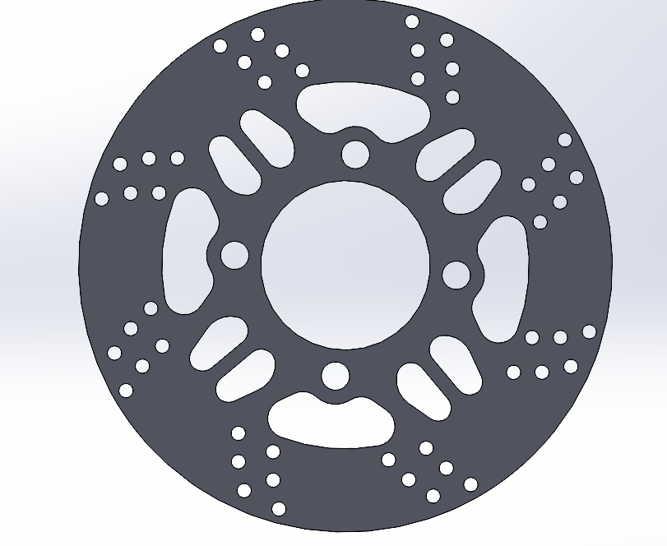
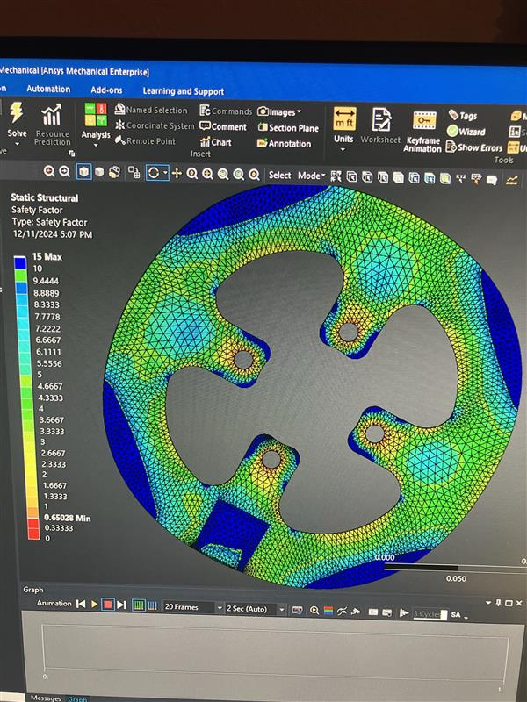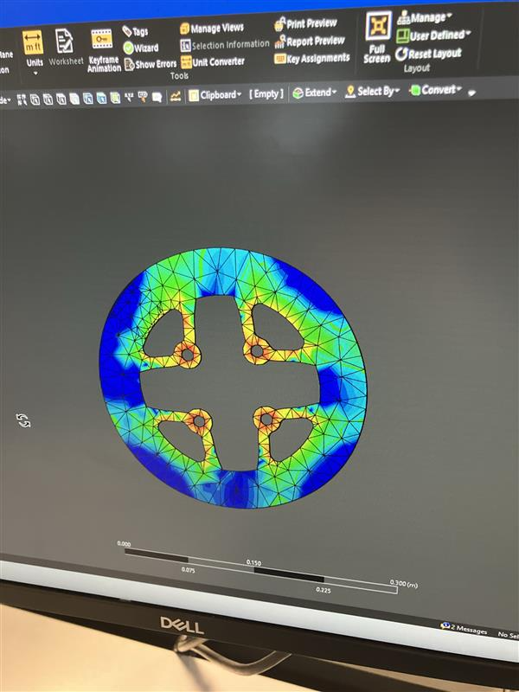
This design was followed by extensive ANSYS analysis thru various static structural loads. The first setup has the four bolt holes fixed, and a “pad” placed on the surface of the rotor puts a certain amount of force down, creating a moment about the center of the rotor. The second setup consisted of the opposite of this, where the pad is fixed and each of the bolt holes create a moment about the center. Both of these approaches are realistic lock-up conditions. From top to bottom, these analyses show equivalent stress in setup 2, life in setup 2, and life in setup 1.
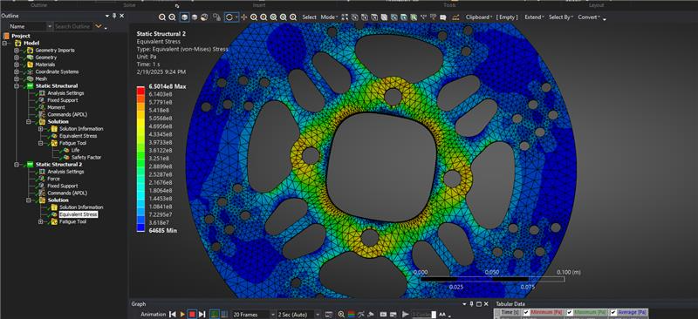
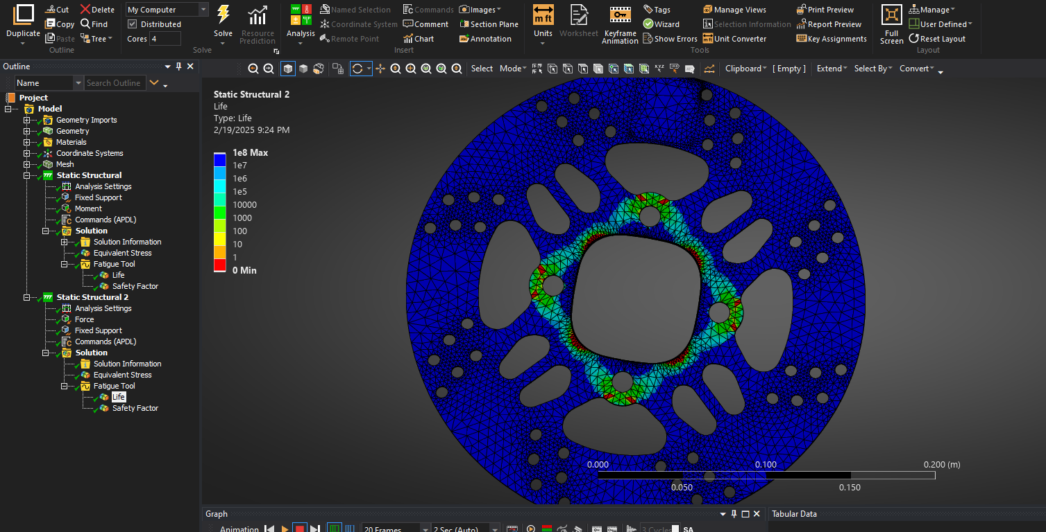
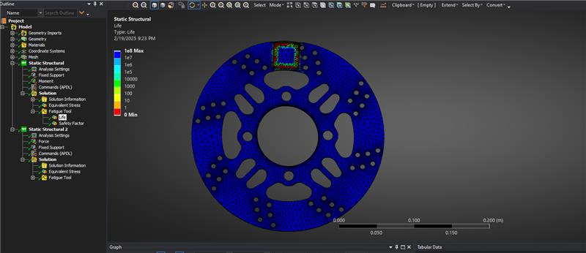
Following this analysis the team decides that the rotor design is complete and it is time to manufacture them.
The pedal box is another significant system that has to be designed part of the braking system. The concept of our pedal box consists of up-right master cylinders with an adjustable pedal ratio and placement. Putting this together into a lightweight compact cavity in the cockpit is easier said than done, so space savings and adjustability will prevail as the priority.
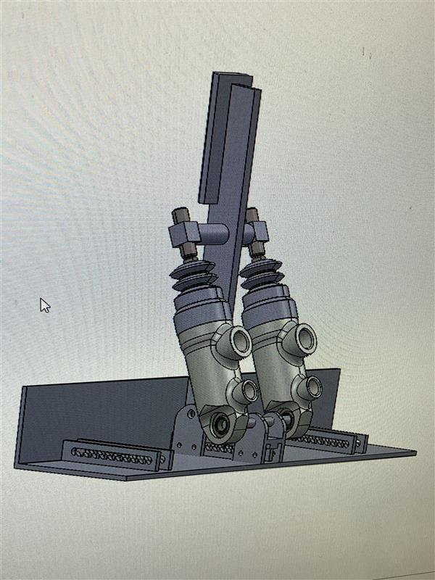
This design incorporates adjustability and simplicity, however this is not totally realistic as the bias bar is a good few inches further away from the top of the master cylinders than we expected, so the rail will have to be extended. An ANSYS model followed however due to the extended computing time a picture was not taken.
6.2.3 Control Arm Assembly (Garrett Pearson)
After assigning material, temperature, and fixed points to my Control Arm in Ansys, the total deformation could be solved. The image below shows that my control arm experiences the most deformation in the center of the control arms. The maximum deformation is about 0.04in which is small enough to not be concerned with. No changes were made to the shape or size of the arm due to the Ansys tests, however it did confirm that the current design would be safe for use in our vehicle.
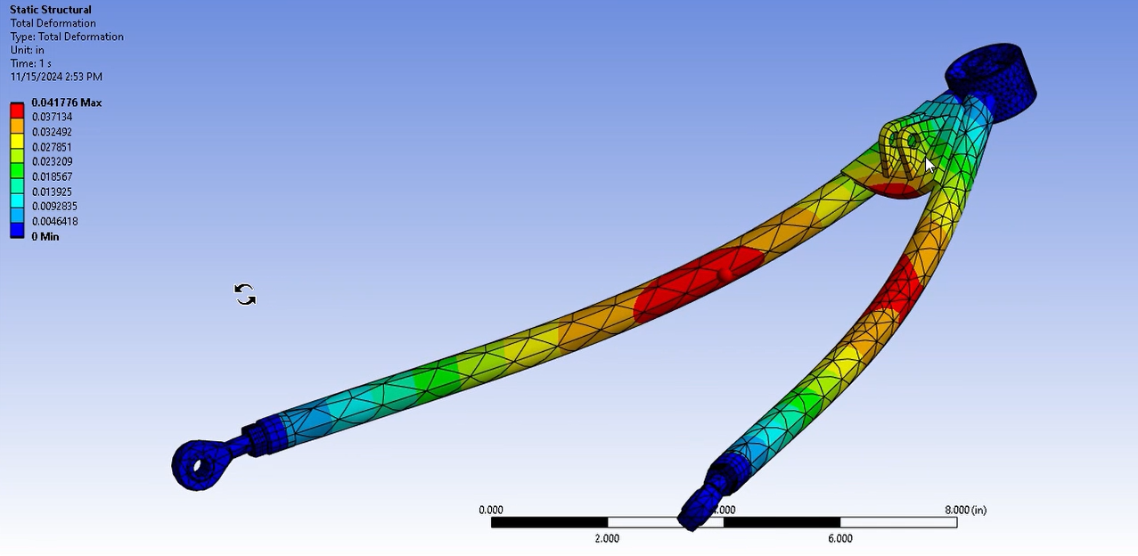

6.2.4 Steering System (Matthew)
The protoype of the steering system sees the steering column evaluated to see what sizes and thickness of the aluminum rod is needed to ensure it survives. The material used is 6061 T6511 Aluminum and for the purposes of testing an experimental force of 200 lb is used to evaluate at a worst-case scenario, with the according torques and forces that this entails. These forces were put into Ansys for analysis and the following images show the results.

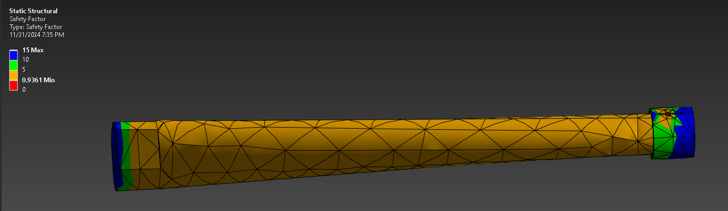

This is the lower half of the steering column, and the current design sees a reinforced connection point to the steering rack to handle the forces in it. This iteration has a great factor of safety at .936 at this force which means that it can handle typical forces in operation or even double forces with no issues. With this information it is almost too overbuilt and would suffer from higher production effort to make as the column must be made of either a singular material that has to be made on the lathe to shave the body down to size or multiple materials with mechanical mounting and a backup weld.

The second part that was evaluated was the half of the steering column that would connect to the steering wheel to make sure it could cope with similar forces.

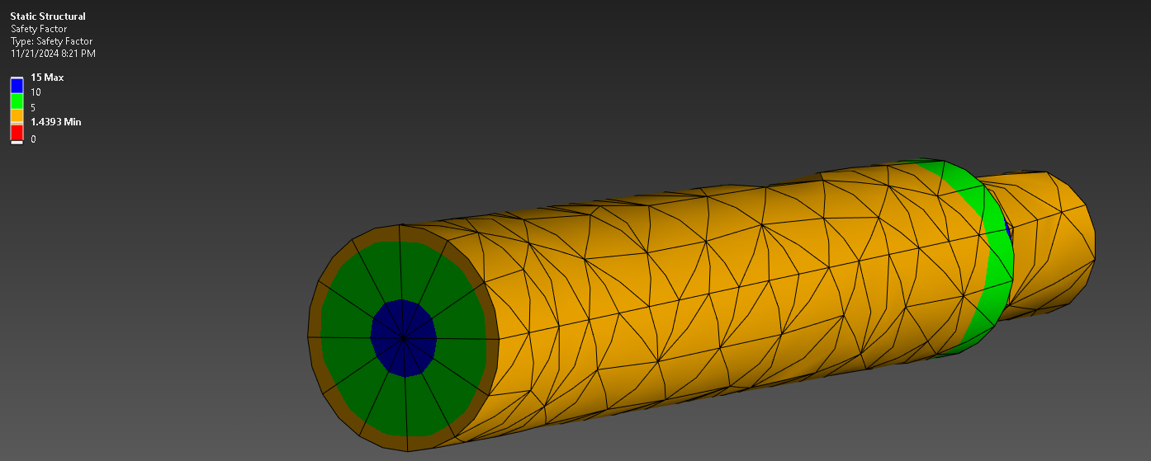

`This part is very durable because even at these high forces it has a factor of safety of 1.44 which means that it can withstand any force that it could see under normal use or even worst case scenario with ease. This part is effectively finalized in this current iteration and both of these parts will undergo a final analysis before construction plans are finalized to ensure the designs are still accurate. This process will be repeated with the tie rods for a similar purpose and the parts will be manufactured at the workshop on NAU campus.
6.2.5 Geometry and Steering Knuckle Prototype (Parker Johnson)
For the initial prototype I decided it would be best to look over the front suspension assembly and do a motion study showing how all the parts interact with each other, and make sure there were no colliding parts. We can see in the figure below that my most recent iteration of the steering knuckles did collide with the lower control arm, so I had to make adjustments in the design for that. However, all other parts were free to move under the condition that we only had three inches of wheel travel, determined from the starting point of ride height.

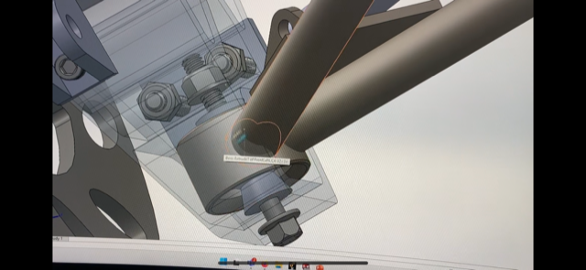

From the figure above we can see where the lower control arm collided with the knuckle when the wheel is fully turned to the right or left.
In the next prototype for the knuckles, we made a 3D printed part to see how the sizing would compare to the parts we intend on using in the assembly, namely the wheel bearing and the snap ring. Since the knuckle was printed to a lower quality, we were not able to get the wheel bearing inside the knuckle. However, we could see how the snap ring would fit to make sure the dimensions for this feature in the knuckle would allow for an easy installation of the snap ring. This prototype did indeed confirm that the current design would work for implementing and installing the wheel bearing and the snap ring. These components are shown in the figure below.
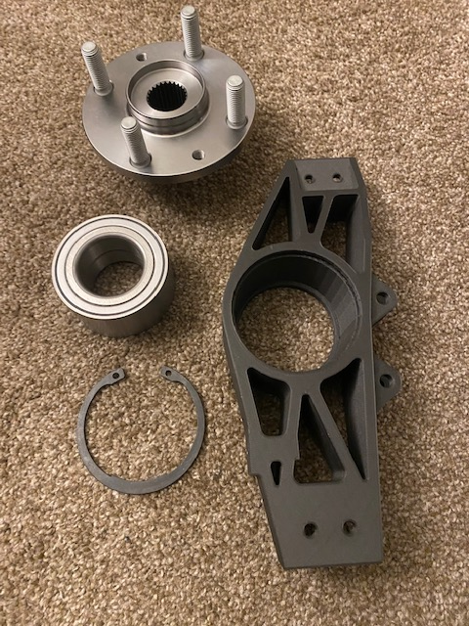

6.3 Other Engineering Calculations
6.3.1 Geometry and Steering Knuckles (Parker Johnson)
As an outcome of this roll analysis done in the earlier 3.1.1 section, we can achieve a reaction force happening on the tire with the increased load. To do this, we used the sum of moments about the roll center and that of the reaction force on the tire at its distance from the centerline of the vehicle. We assumed worse case scenario to be full forces of roll bump and brake, which resulted of a reaction force of nearly 4000N vertically on the tire. This resulted in the calculations shown below.
Figure 5: Hand Calculations

We can see that the lower control arm is in 4000N of compression, with a bending moment acting on the control arm from the pushrod. The upper control arm is in 1500 N of tension. All these values were calculated by assuming some points were fixed in space, such as the lower and upper control arm pivot points on the left side (chassis mounts). Analyzing each side one by one we were able to achieve these values.
From these reaction forces, we can then use the total pushrod axial force calculated to find our desired spring rate looking at our pushrod geometry. A MATLAB code was generated for this using simple geometry in the design and analyzing different positions through its range of motion and taking the angles between different components to see how the forces transfer. From our rocker arms motion ratio of 1.4, we can find that the force applied to the spring at full travel is around 3100 N for 1.8 inches of travel, resulting in a spring rate of 500 Lbs./in. This seems reasonable since last year used 200 Lbs./in, they had a motion ratio of 1, and the suspension frequently bottomed out from more miniscule forces, causing the car to handle poorly in some situations.
Using Excel, we can input our resulting pushrod and tire forces at different travel positions to find how much droop and bump our suspension will have. This is shown in the graph below.
Figure 6: Travel position vs. Vertical tire force

Having a static load of 600 N to the wheel, we can easily find our ride height and our travel numbers from this data with a 500 Lbs./in spring rate.

Table 1: Travel position at ride height and full cornering forces

The above table shows results of ride height as well as full cornering in the vehicle. Conservative numbers were used in the calculations for tire force, so it may be likely we will need to choose a lower spring rate after the first round of testing. The left shows the vertical travel position at ride height (static) and the right shows the vertical travel position during 2gs of lateral acceleration. This spring rate allows for any possibility of a bump load happening during cornering, and with these numbers we are confident the vehicle will handle appropriately even in harsh conditions.
6.3.2 Pushrod Assembly (Joseph)
Updated pushrod buckling calculations were done with new information of the material and updated length
$$P_{cr}={\left(\frac{\left(πEI\right)}{KL}\right)}^{2}$$

^{I =(π(.25 in)4)/4= .00307 in4}
Pcr= (π2*(10*106 psi ) * .00307 in4)/(1.0*22.1 in)2= 620.4 Ibf

^{Variables:}
^{P}_{cr} ^{= Critical Load}
E = Young's modulus of pushrod material
^{(aluminum 10*106 psi)}
I = Aera moment of inertia of pushrod cross-section
^{L = Length of pushrod}
^{(22.1 in*this will change)}
K = Column effective length factor
^{(1.0)}

6.4 Future Testing Potential
6.4.1 Steering Assembly (Matthew)
The testing of these parts will comprise of force tests to ensure that the material is easier to turn for the comfort of the driver through steering in multiple conditions including sitting still to ensure functionality is at the fullest. Along with this tuning will be done to the tie rods to control the toe in on the front and rear for driver comfort and vehicle stability in the conditions it will see. The largest concern for the vehicle is an unpredictable steering feel and the highest amount of effort will be put forth so that issue is fully addressed before competition.
Since the design has been finalized and constructed some initial simple tests with the steering system have been done with basic turning of the wheel functions and it is already an improvement from the vehicle from last year as it can move quite easily from lock to lock. When the vehicle is in fully driving the full extent of testing during hard turning can be done to ensure it can hold up under the worst conditions.
6.4.2 Pushrod Assembly (Joseph)
Testing for the rocker arm will check for fatigue in the material such as micro cracks or heavy deformation. If weak points occur a redesign will be needed to fix the issues. The largest concern is the cutout areas for weight savings, through FEA it showed some increase stress in the corners of these cutouts but nothing too extreme. Another planned test is the use of various spring rates for the dampers. A few different springs have been selected for testing and will be evaluated during car testing by driver feedback and performance.
6.4.3 Knuckles and overall geometry (Parker Johnson)
In the first stages of testing, we should be able to easily notice the steering effort required to operate the vehicle, and this can be adjusted by changing the location of the upper ball joint in relation to the knuckle. By doing so will change the caster or static camber in the front suspension which directly effects the steering effort required. The only downside to this is that the total camber change will decrease dynamically, so we will have to compensate by adding more static camber. This in turn will decrease the traction our tires will see in a straight line, but will add more traction through corners, which is the condition the car will be seeing the most during competition.
We can also adjust the length of the control arms and their mounting location on the chassis, which directly effects the roll center as well as the static camber. Based off our results from the first testing session will determine the correct amount of adjustment that are needed for both the upper ball joint as well as the control arm lengths and their mounting locations on the chassis.

6.4.4 Braking System (Chris)
The best form of testing for the brakes comes hand in hand with other forms of the suspension geometry. Autocross in general and straight line braking are about all that is needed for braking testing. The two factors that need to be taken into consideration are that the brakes can be locked up and that thermally they can deal with a ~30 minute hot track session. This will be tested simultaneously with other suspension components when we have a designated area with time to test.

Final Hardware

Final Physical Design
Summarize all aspects of your physical design – starting from a top-level/sub-assembly view of the actual real-world solution then go down into the individual parts worth highlighting that you designed. Use real pictures next to CAD images to help with this conversation. Show design iterations that were valuable to your project.

A-Arms
Our final design incorporated a total of eight custom A-arms: two front upper, two front lower, two rear upper, and two rear lower arms. Each pair of arms featured a unique design and was constructed using two steel tubes, two threaded inserts, two rod ends, a bearing, and a bearing cup. These A-arms were securely bolted to multi-slot adjustable brackets, which were welded directly to the vehicle’s frame to allow for fine-tuned suspension adjustments.
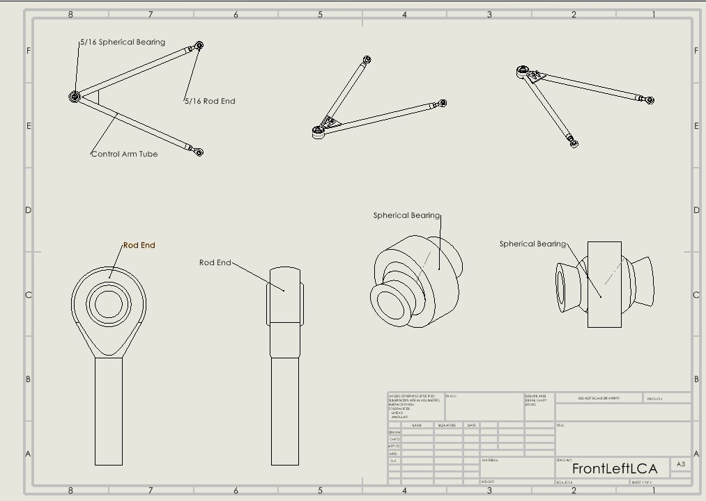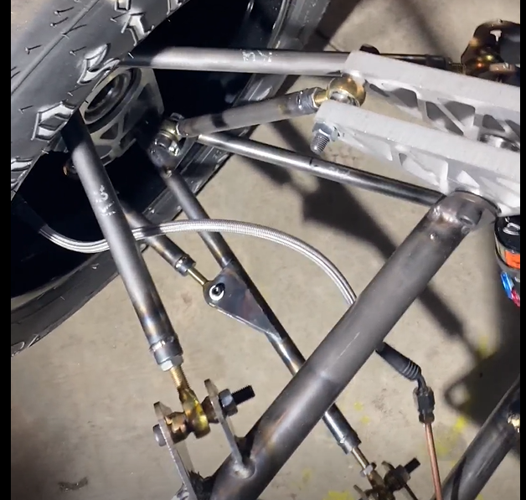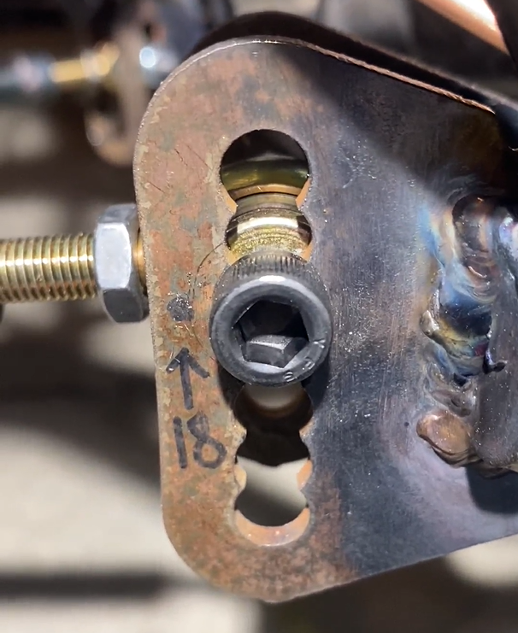

Steering System

The steering system has seen some of the least iteration of all of the parts as after design and building it has more or less kept the same components with only slight alterations to the angles of the double u joint of length of the column. The general layout of the column is shown below where it attaches to the steering rack that then attaches to the tie rod.
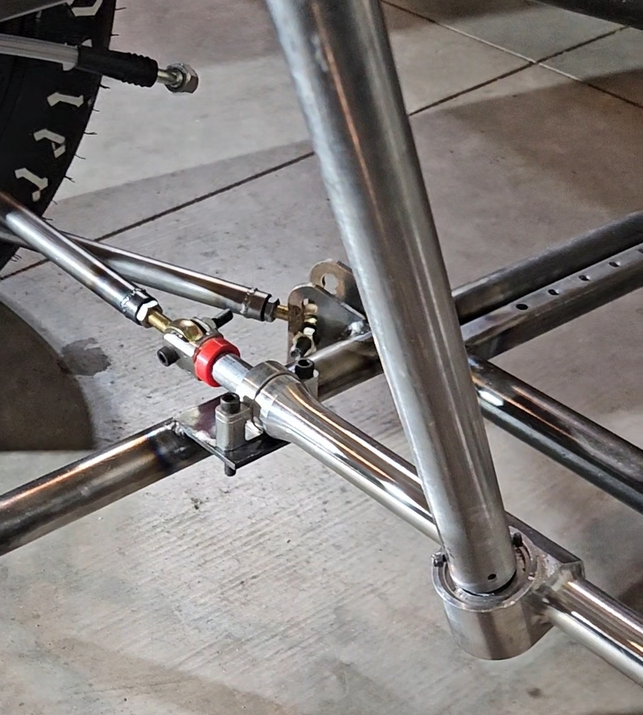

The largest change that has been made to the system is the mounting system as originally it was using two pillow block brackets but now it uses one pillow block on top then a heim joint on the bottom to conform to the ruleset.
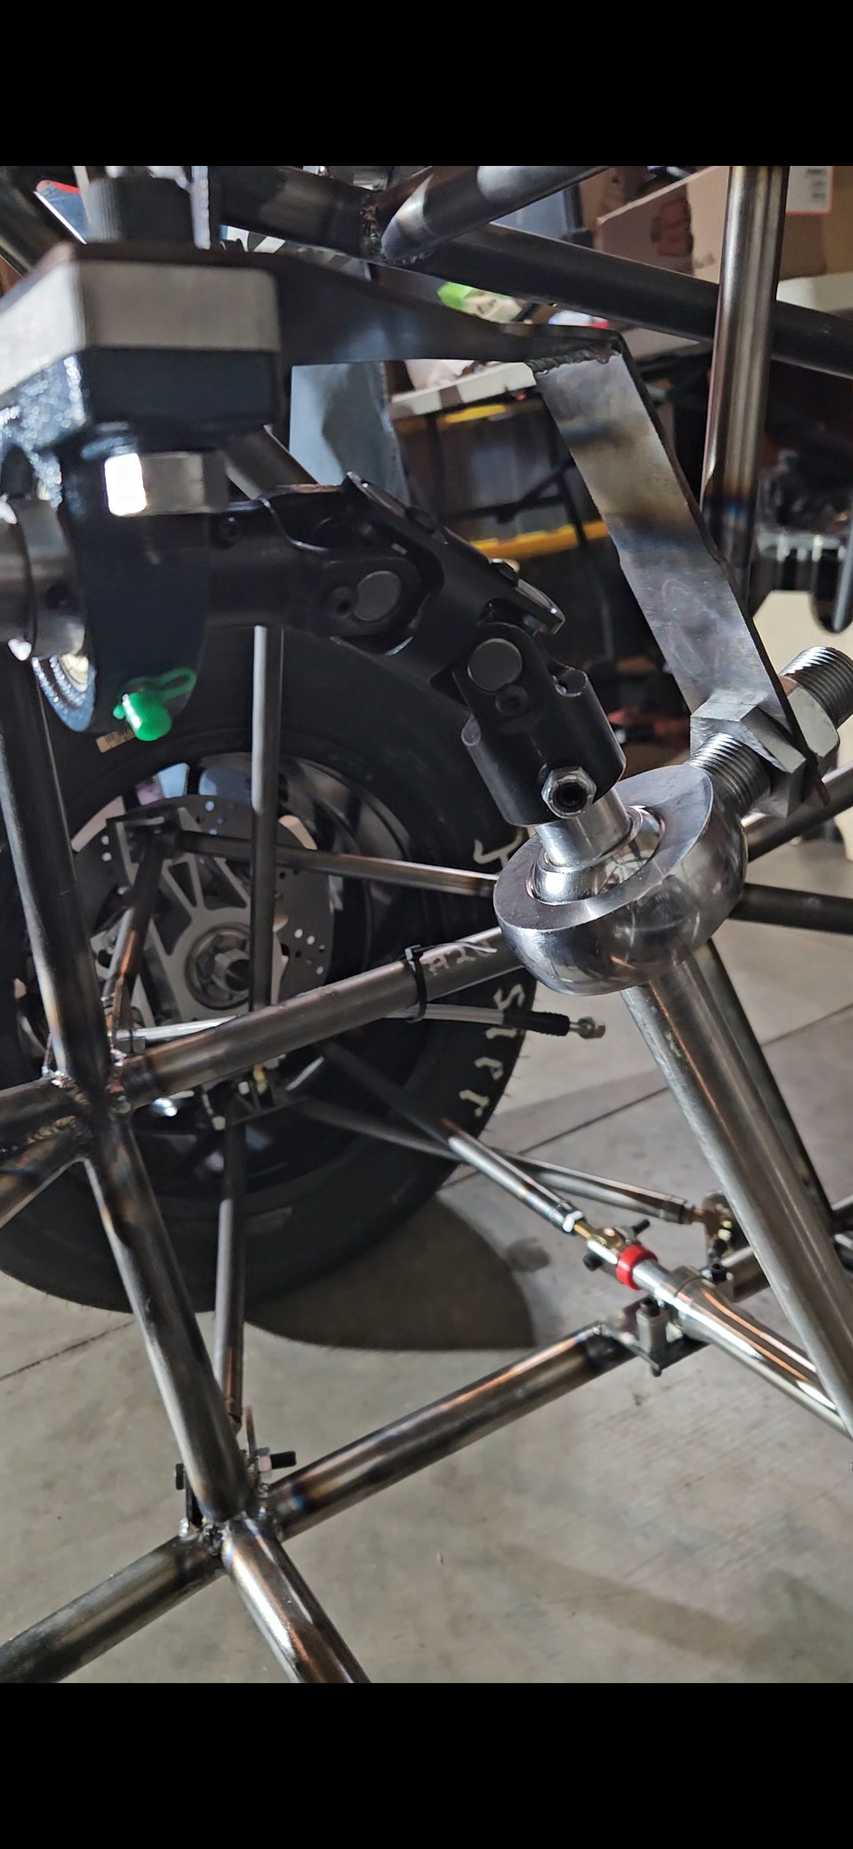

Aside from this the design has been kept simple and robust so all that is left is the testing to ensure that all the work that went into this system has been done correctly.

Wheel Hubs
The wheel hubs are a critical interface between the vehicle's suspension system and the wheels, responsible for supporting radial and axial loads while enabling smooth rotation. For the 2025 Lumberjack Racing FSAE car, the design strategy focused on adapting a proven production component to maximize reliability and ease of manufacturing. No major changes were made between the initial and final designs, reflecting a successful early choice that met all performance and manufacturability goals.
To achieve these objectives, rear wheel hubs from a 1990-2005 Mazda Miata were selected for both the front and rear of the car. These hubs offer a balance of compactness, durability, and availability of replacement parts, making them an ideal choice for a student-built racecar. Each hub assembly consists of a double-row deep-groove ball bearing, providing strong radial and thrust load capacity critical for high lateral forces experienced during racing.
The integration of the hubs into the suspension required precision mounting within the steering knuckles. A tight slip fit between the hub outer diameter and the knuckle bore was maintained to ensure proper bearing seating without excessive preload. A snap ring groove was included in the knuckle design to securely retain the hub, preventing axial displacement under racing loads. During manufacturing, the knuckle bores were carefully dimensioned based on Miata bearing specifications to maintain tight tolerances critical for bearing longevity.
Below is the CAD representation of the wheel hub and its integration into the steering knuckle:
Assembly of the hubs involved pressing the bearings into the knuckles, followed by securing the hubs with appropriate snap rings and torquing the axle nuts to specification. The final physical hubs showed excellent fitment within the suspension geometry and operated with minimal resistance, ensuring optimal performance for dynamic events.
Shown below is the final installed picture of the wheel hubs on the vehicle:
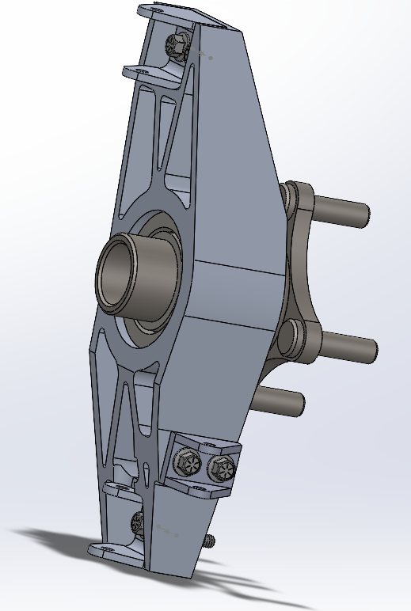
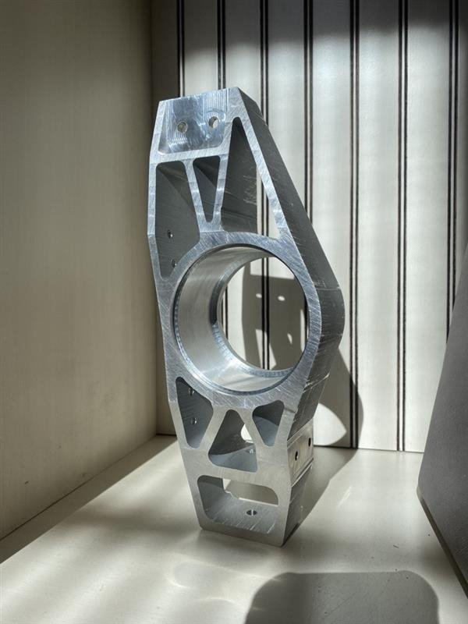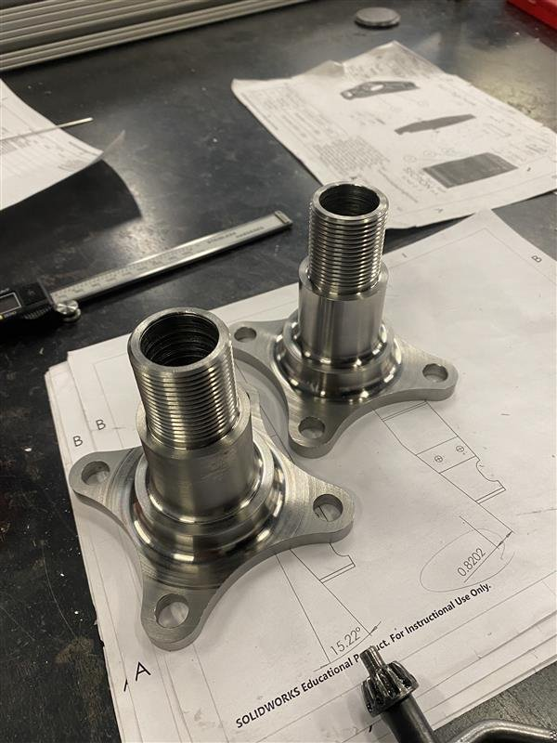
In conclusion, the decision to use production Miata hubs streamlined the design and manufacturing phases, reduced risk by relying on a proven, durable component, and allowed the team to focus resources on more custom-designed areas like the steering knuckles and rocker arms. Their successful integration demonstrates how leveraging existing automotive components can be an effective strategy in Formula SAE vehicle development.

Brake System
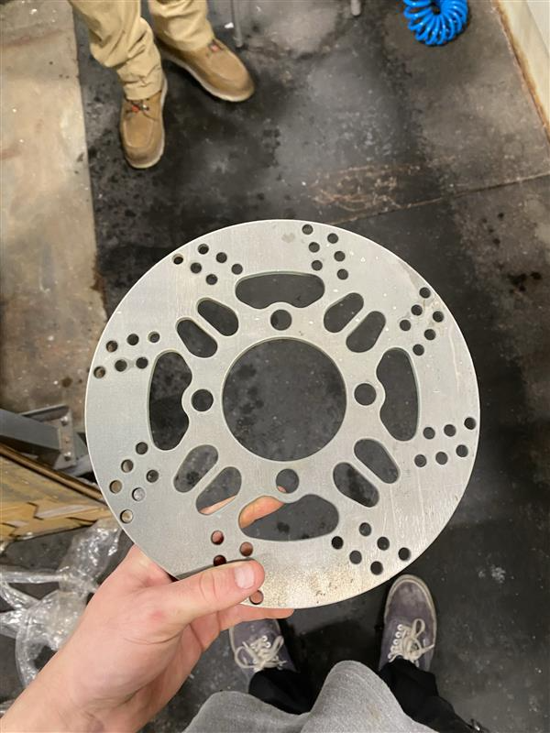
The team received a great sponsorship from a waterjet facility, and they helped us out a huge amount in making us able to bring complex 2d shapes to life. The rotors turned out well and they fit well onto the hubs with some filing/fitting, however, do not fit in the center of the brake caliper. The bracket will have to be adjusted accordingly to get this more centered, imperfection is fine. These rotors are 5/32” thick and made from 4130 steel. The cross-drilling design is for weight reduction and cooling, along with the cut-puts around the lug bolts. Cooling in the braking system of a racing machine is important to keep the car safe and consistent.
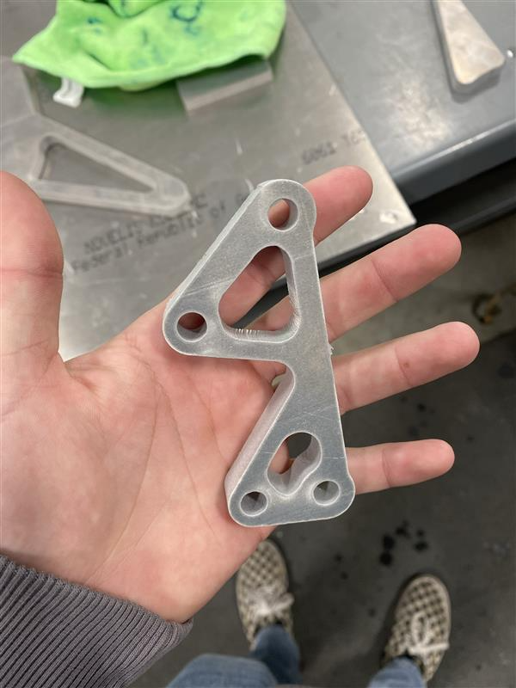
The brake caliper brackets were also water jet cut. They also turned out well, however were difficult to machine due to the complex shape. Using the excess water jet scraps as soft jaws worked well to solve this problem and made it easier to face the brackets on the manual mill.
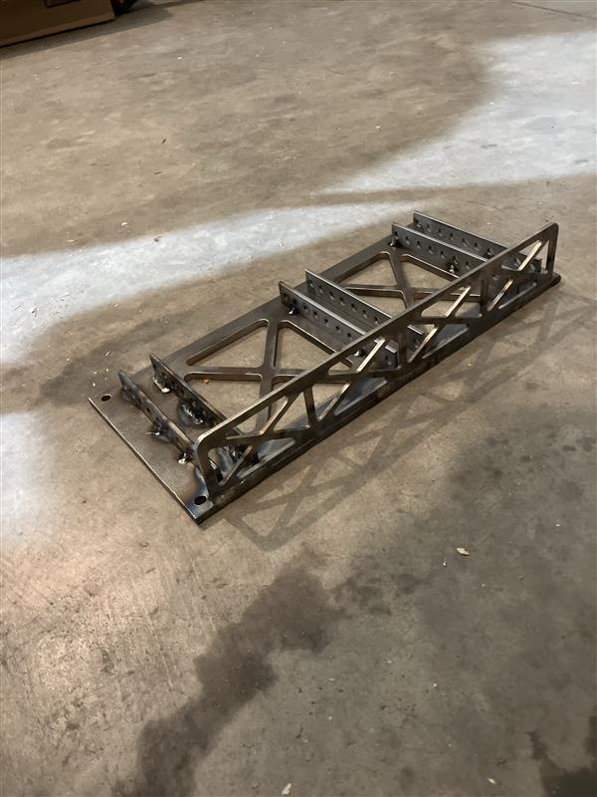
The pedal box was also initially water jet cut. This design was slightly altered from the CAD models in that we spaced out the pedals more because we had space inside the cockpit. After many hours of welding, sanding, filing, and re-drilling, everything fits well.

Pushrod System
The front pushrod system went over a few changes based off Ansys fea results. The final design ended with improving strength of some areas to achieve the safety factor to acceptable areas. Each racker arm was made of aluminum including the spacers and using grade 8 steel hardware.
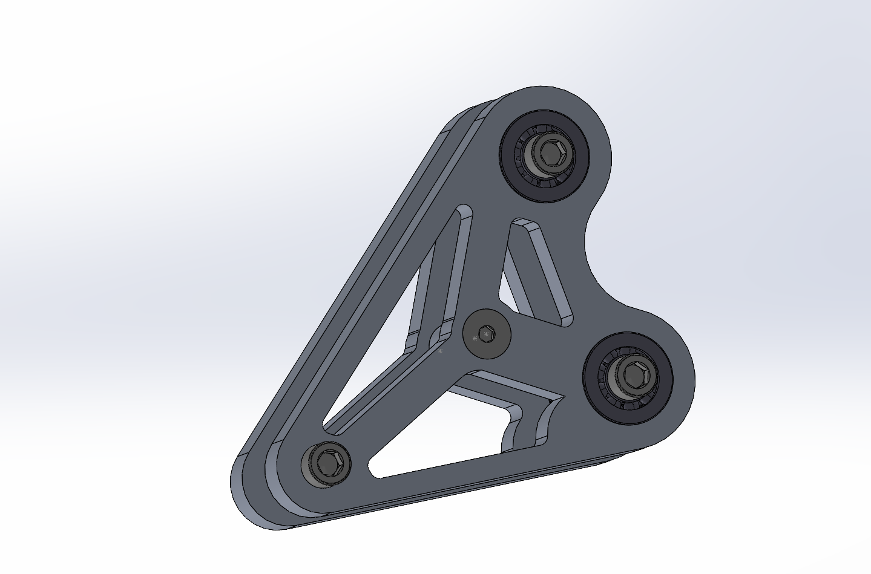
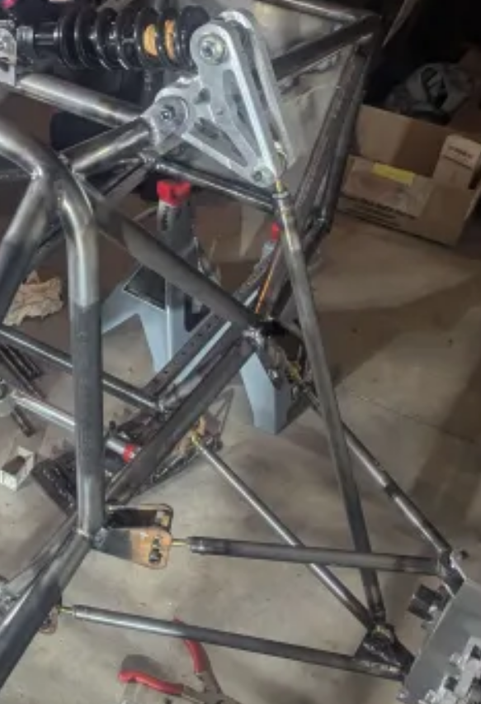

The rear design took the lessons from weight reduction of the front and the final design was done after one iteration.
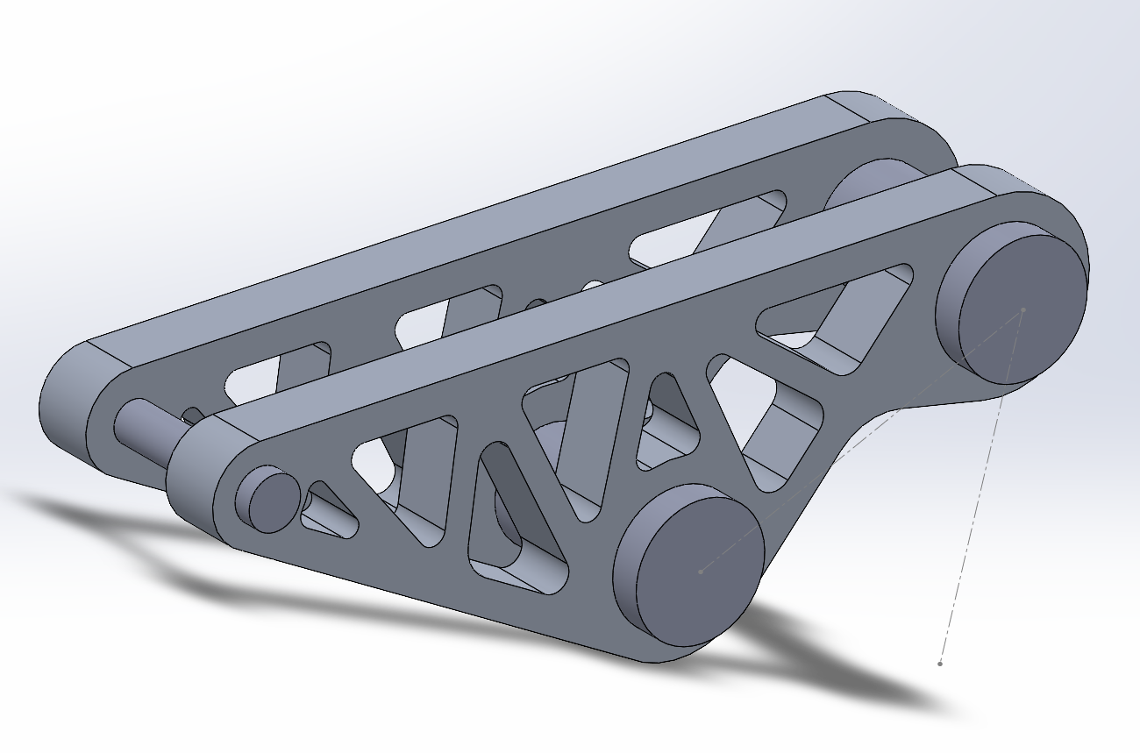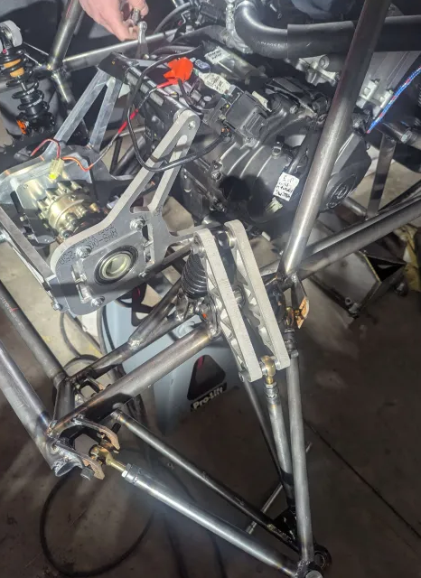

Final Testing

Top level testing summary table

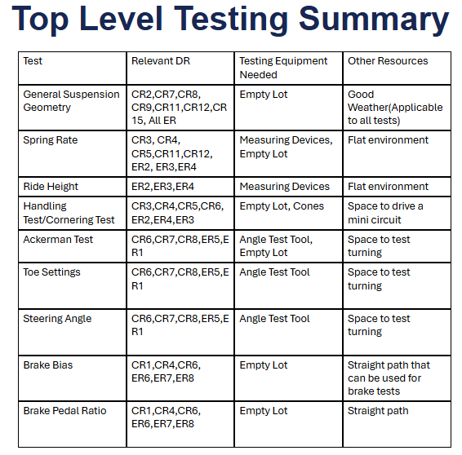
The Top-Level Testing Summary table outlines the key tests planned for validating our Formula SAE suspension and braking systems. Each row identifies a specific test—ranging from general suspension geometry to brake pedal ratio—along with its associated design requirements (DR), the equipment needed, and any additional resources required. This structured approach ensures that each subsystem is rigorously evaluated under appropriate conditions using the correct tools, such as measuring devices, angle test tools, or cones in an empty lot. The summary also highlights environmental factors like flat terrain and good weather, emphasizing our focus on reliable and consistent testing outcomes.

Detailed Testing Plan

Test 1: Generalized Suspension Geometry

Summary
The Generalized Suspension Geometry Test was designed to validate whether the physical layout of the suspension met key design and competition requirements. Specifically, the goal was to measure the wheelbase and track widths to ensure conformity with engineering requirements such as minimum wheelbase and proper weight distribution. These measurements are critical for handling characteristics, packaging of components, and overall chassis performance.

Procedure
The team fully assembled the suspension as it would appear during a competition event. Using tape measures, they recorded the wheelbase and both front and rear track widths. Measurements were taken with the vehicle on a flat surface to ensure consistency and accuracy.

Results
The final measured wheelbase was 63 inches, exceeding the minimum requirement of 60 inches. The front track width measured 49.5 inches, and the rear track width was 48.5 inches. These values fall within the expected range, confirming that the suspension geometry aligns with both performance goals and rulebook specifications.

Test 2: Ride Height

Summary
The Ride Height Test aimed to verify that the vehicle maintains proper ground clearance under both static and loaded conditions. Ride height directly affects the center of gravity, suspension travel, and handling stability, making it essential for performance and rule compliance.

Procedure
With the suspension fully assembled, the vehicle was placed on a flat surface and its lowest point was measured using a tape measure. Measurements were taken both with and without a driver seated in the car to evaluate how driver weight impacts ride height. The test was repeated using a range of driver weights to assess variability.

Results
The lowest point of the vehicle measured 2.25 inches from the ground with a driver seated, which satisfies the requirement of maintaining a ride height under the 3-inch maximum. This confirms the suspension system provides adequate clearance while keeping the center of gravity low for improved performance.

Test 3: Spring Rate

Summary
The Spring Rate Test was conducted to evaluate how the suspension responds under loading and to determine whether the spring characteristics align with the intended progressive behavior. Proper spring tuning is critical for optimizing handling, comfort, and maintaining desired ride height across varying loads.

Procedure
The vehicle was placed on a flat surface and subjected to increasing vertical loads on both the front and rear suspension. The resulting suspension compression (travel) was measured to observe how the springs responded to changes in force. This data was then used to calculate the spring rate and verify progression throughout the travel range.

Results
Initial loading caused approximately 0.75 inches of uptravel under the vehicle's weight, indicating a softer initial spring response. As the load increased, the spring rate also increased, confirming a progressive stiffness characteristic. The results aligned well with the expected progressive rate design, supporting effective load management and dynamic performance.

Test 4: Ackerman Angle

Summary
The Ackerman Test was performed to evaluate the effectiveness of the steering geometry in producing desirable turning characteristics. Achieving positive Ackerman geometry is essential for improving cornering performance by ensuring that each front wheel follows an appropriate turning radius during steering.

Procedure
The vehicle's wheels were turned to full lock in both left and right directions. Using an angle gauge, string, and measuring tape, the individual angles of the inner and outer front wheels were measured. These measurements were used to calculate the Ackerman percentage based on the deviation from ideal steering geometry.

Results
The test yielded a positive Ackerman value of 50%, which falls within acceptable performance parameters. This confirmed that the steering system is effectively designed to improve low-speed maneuverability and reduce tire scrub during cornering.

Test 5: Steering Angle

Summary
The Steering Angle Test aimed to quantify the steering response by measuring the angles achieved by both the inner and outer front wheels at full lock. Understanding these angles is important for analyzing steering effectiveness and validating the Ackerman geometry under real conditions.

Procedure
With the vehicle stationary, the steering wheel was turned to full lock in both directions. Using an angle gauge and measuring tape, the inner and outer wheel angles were recorded. These values were used to assess steering range and the angle differential between the tires.

Results
The inner front wheel achieved a maximum angle of 31 degrees, while the outer wheel reached 28 degrees, resulting in a consistent 3–4 degree difference. These values confirm the proper function of the steering geometry and indicate predictable, responsive steering behavior.

Test 6: Toe Settings

Summary
The Toe Settings Test was conducted to determine the static toe alignment of the vehicle’s wheels. Proper toe alignment is critical for stability, tire wear, and predictable handling characteristics during cornering and braking.

Procedure
With the wheels set to a neutral steering position, measurements were taken from the front and rear edges of the tires using a tape measure, angle gauge, and string. The differences in these measurements were used to calculate toe-in or toe-out for both the front and rear axles.

Results
The vehicle exhibited 1/8 inch of toe-out at the front and 1/8 inch of toe-in at the rear. These settings align with the intended design, promoting responsive turn-in at the front and enhanced stability at the rear during high-speed driving and cornering.

Test 7: Brake Bias

Summary
The Brake Bias Test was designed to evaluate whether the vehicle’s braking system provides balanced braking force across all four wheels. Achieving even brake lock-up is crucial for maintaining control under hard braking and is a requirement for competition safety inspections.

Procedure
A skid pad test was simulated in an empty parking lot with the master cylinder position as the isolated variable. The vehicle was driven in a straight line and brakes were applied abruptly to observe whether the front and rear wheels locked simultaneously or unevenly.

Results
The results showed that all four brakes locked up at the same time, confirming balanced brake bias. This outcome satisfies competition requirements and ensures that the braking system delivers consistent and predictable performance.

Future Work
For future testing and development, our goal is to build on the progress made this year by fostering collaboration with future NAU FSAE capstone students. By working closely with incoming teams, we can pass on knowledge, refine designs, and create a stronger foundation for continued improvement. Exploring more effective manufacturing methods will also be a priority, as this can lead to improved part quality and reduced production time. Just as important, we plan to help ensure that future teams are well-structured and composed of dedicated members who are aligned with the project’s goals. Starting the design process early will give future teams a head start, allowing them more time for validation, testing, and refinement throughout the academic year.

CONCLUSIONS
The Formula Student project represents a significant educational opportunity for our team, challenging us to design and build a competitive race car while adhering to rigorous standards. Our primary objective is a fully functional vehicle that passes technical inspection and competes successfully in all events. Learning from last year's experiences, we aim to enhance our car's reliability, adjustability, and overall performance, targeting an improvement in our competition ranking.
To achieve these goals, we have carefully transformed customer requirements into actionable engineering deliverables, drawing from both our faculty advisor's guidance and the FSAE Rulebook. These requirements set a strong foundation for our design and manufacturing processes, ensuring that safety, performance, and FSAE compliance are achieved.
As we progress, our focus will remain on thorough testing and early completion of the car, addressing the challenges faced in previous competitions. By using efficient methods like Functional Decompositions, Decision Matrixes, Pugh Charts, and collaboration within our team, we look to not only meeting but exceed the expectations of last year's team, ultimately aiming for a successful experience at the FSAE competition.

REFERENCES

[1] D. L. Milliken and W. F. Milliken, Race Car Vehicle Dynamics: Problems, Answers, and Experiments. Warrendale, PA: SAE International, 2003.
[2] J. C. Dixon, Suspension Geometry and Computation. Chichester, U.K: Wiley, 2009.
[3] E. F. Gaffney and A. R. Salinas, Introduction to Formula SAE® Suspension and Frame Design. Warrendale, Pa: Society of Automotive Engineers, 1997.
[4] G. Valdo and C. Rouelle, “FSAE front axle optimization using OptimumKinematics optimization module,” OptimumG, https://optimumg.com/fsae-front-axle-optimization-using-optimumkinematics-optimization-module/ (accessed Sep. 16, 2024).
[5] R/FSAE on reddit: Scrub radius and mechanical trail help, https://www.reddit.com/r/FSAE/comments/1dbmr01/scrub_radius_and_mechanical_trail_help/ (accessed Sep. 16, 2024).
[6] “Vehicle suspension: Front view online suspension simulator,” Vehicle Suspension: Front View Online Suspension Simulator, https://vsusp.com
[7] S. Ranganathan, S. gopal, S. eswaran, and S. muthusamy, “Design and analysis of steering knuckle for FSAE vehicle,” SAE International Journal of Advances and Current Practices in Mobility, https://www.sae.org/publications/technical-papers/content/2020-28-0506/ (accessed Sep. 16, 2024).
[8] S. Yaeger et al., “Designjudges.com,” DesignJudges.com, https://www.designjudges.com/ (accessed Oct. 20, 2024).
[9] “Circuit Tire Specifications.” Hoosier Racing Tires, www.hoosiertire.com/news/article/64377/Circuit_Series_Tire_Specs. Accessed 16 Sept. 2024.

[10] R. P. Tata, Ball Bearing Design & Application, https://www.cedengineering.com/userfiles/Ball Bearing Design and Applications R1.pdf (accessed Nov. 27, 2024).

[11] Webteam, “How to determine bearing shaft and housing fit - baart group,” Baart Industrial Group, https://baartgroup.com/how-to-determine-bearing-shaft-and-housing-fit/ (accessed Nov. 27, 2024).

[12] Gupta3, Eshaan, et al. “Design and analysis of brake system for FSAE race car” Engineering Research Express, IOP Publishing, 25 Apr. 2022, iopscience.iop.org/article/10.1088/2631-8695/ac6ecd.

[13] Markel, Andrew. “Brake Math: Calculating the Force Needed to Stop a Car.” Brake & Front End, 5 Nov. 2020, www.brakeandfrontend.com/brake-math-calculating-the-force-needed-to-stop-a-car/.

[14] Milliken, William F., 1911-2012. Race Car Vehicle Dynamics. Warrendale, PA :Society of Automotive Engineers, 1995.
Chapters 2, 10, 11, 12, 18, 20

[15] Mora, Luis Alberto. Design of a FSAE Braking System, Massachusetts Institute of Technology, 1 Jan. 2018, dspace.mit.edu/handle/1721.1/119947.

[16] Schiller, Brad W. “2007 Formula SAE Pedal Box.” 2007 Formula SAE Pedal Box, Massachusetts Institute of Technology, 1 Jan. 2007, dspace.mit.edu/handle/1721.1/40481?show=full.

[17] Shivkumar Mirajgave, et al. “Design and Cost Effective Manufacturing of Swivelling Brake Master Cylinder for a Formula Student Vehicle.” Materials Today: Proceedings, Elsevier, 2 Jan. 2023, www.sciencedirect.com/science/article/pii/S2214785322074740.

[18] Tom McCready and James Walker, Jr. of SCR motorsports. “Brake Bias and Performance.” Brakes, www.brakes-shop.com/brakepedia/general/brake-bias-and-performance. Accessed 16 Sept. 2024.
[19] J. Reimpell, J. Betzler, and H. Stoll, The Automotive Chassis, Hodder Education, 2000.
[20] W. F. Milliken, Race Car Vehicle Dynamics and Workbook, Soc. of Automotive Eng., 1998.
[21] Y. S. Saurabh et al., “Design of Suspension System for Formula Student Race Car,” Procedia - Engineering, vol. 144, pp. 1138–1149, 2016, doi: https://doi.org/10.1016/j.proeng.2016.05.081
[22]
Z. Shuping, Y. Zengjie, and X. Lei, “Research on the Topology Optimization of the rocker arm of compression garbage truck based on Rigid-Flexible coupling,” IOP Conference Series: Materials Science and Engineering, vol. 423, p. 012107, Nov. 2018, doi: https://doi.org/10.1088/1757-899x/423/1/012107.
[23]
Hanmant Shete, “Failure analysis and optimization of rocker arm,” Research on the Topology Optimization of the rocker arm of compression garbage truck based on Rigid-Flexible coupling, vol. 9, no. 5, pp. 118–126, Jan. 2020, Accessed: Nov. 27, 2024. [Online]. Available: https://www.researchgate.net/publication/343047793_Failure_analysis_and_optimization_of_rocker_arm

[24] K. B. Evseev and A. B. Kartashov, “Search for optimal design parameters of suspension arms for -Formula Student race car,” Izvestiya MGTU MAMI, vol. 9, no. 3–1, pp. 32–37, Feb. 2015, doi: https://doi.org/10.17816/2074-0530-67179.
[25]A. A. Vadhe, “Design and Optimization of Formula SAE Suspension System,” International Journal of Current Engineering and Technology, vol. 8, no. 3, May 2018, doi: https://doi.org/10.14741/ijcet/v.8.3.17.
[26] “Automotive Suspension - MATLAB & Simulink,” www.mathworks.com.
[27]“Suspension Design Series,” YouTube, http://www.youtube.com/playlist?list=PLfNrVTkV8cM_kaP29HJqIXWjDcHNv-cqs (accessed Sep. 16, 2024).
Summitracing.com, 2024. https://www.summitracing.com/search/part-type/coilover-springs/product-line/hyperco-formula-sae-coilover-springs (accessed Sep. 19, 2024).
[28]A. Cobi, “Design of a Carbon Fiber Suspension System for FSAE Applications,” 2012. Available: https://dspace.mit.edu/bitstream/handle/1721.1/74433/813136157-MIT.pdf

[29]“Our Cars – Illini Motorsports.” https://motorsports.illinois.edu/our-cars-2/
[30]“B24 – Berkeley Formula Racing,” Berkeley.edu, 2024. https://fsae.studentorg.berkeley.edu/b24/ (accessed Oct. 20, 2024).
[31]Shafi Md Istiak, Md Rokunuzzaman, and M. A. Islam, “Design of suspension system for formula student race car,” International Conference on Mechanical, Industrial and Materials Engineering 2019, Dec. 2019, Accessed: Oct. 20, 2024. [Online]. Available: https://www.researchgate.net/publication/363196220_Design_of_suspension_system_for_formula_student_race_car
[32]L. Sun, Z. Deng, and Q. Zhang, “Design and Strength Analysis of FSAE Suspension,” The Open Mechanical Engineering Journal, vol. 8, no. 1, pp. 414–418, Dec. 2014, doi: https://doi.org/10.2174/1874155x01408010414.
[33] H. Zhao, Y. Chen, and X. Liu, “Lightweight Design of the Vehicle Suspension Control Arm,” Proceedings of 5th International Conference on Vehicle, Mechanical and Electrical Engineering, 2019, doi: https://doi.org/10.5220/0008849300210025.‌
[34] P. Andrea, C. Santamaría, A. Sierra, O. Andrés González Estrada, and O. Andrés González, “Stress analysis of a suspension control arm.” Available: https://hal.science/hal-01916247/document
[35] J. C. Dixon, Suspension Geometry and Computation. Chichester, U.K: Wiley, 2009.

[36] J. Rodriguez et al., “Automotive Steering System Preferences evaluated using a driving simulator - International Journal of Automotive Technology,” SpringerLink, https://link.springer.com/article/10.1007/s12239-016-0006-0?error=cookies_not_supported&code=651a5789-c052-4355-9167-d85115dbe9d2 (accessed Sep. 15, 2024).

[37] H. Chase, A study of modern automotive-vehicle steering-systems on JSTOR, https://www.jstor.org/stable/44723675 (accessed Sep. 16, 2024).

[38] J. Vogel, “Tech explained: Ackermann Steering Geometry,” Racecar Engineering, https://www.racecar-engineering.com/articles/tech-explained-ackermann-steering-geometry/ (accessed Sep. 16, 2024).

[39] Racelogic, “Slip angle explained,” https://www.racelogic.co.uk/_downloads/vbox/Application_Notes/Slip%20Angle%20Explained.pdf (accessed Sep. 16, 2024).

[40] D. G. Bhosale, Shubham Lilakant Rahate, K. Rege, and Sakthivel Palanivelu, “To Study the Influence of Variation in Camber and Toe on Handling of Passenger Vehicle during Cornering,” SAE technical paper series, Jan. 2019, doi: https://doi.org/10.4271/2019-26-0073

[41] U. Kulkarni, H. Gowda, and Hima Kiran Venna, “Effect of Tie Rod Length Variation on Bump Steer,” Feb. 2016, doi: https://doi.org/10.4271/2016-28-0201
[42] Design & Manufacturing of steering system for FSAE vehicle, https://www.ijert.org/research/design-manufacturing-of-steering-system-for-fsae-vehicle-IJERTV10IS090149.pdf (accessed Nov. 28, 2024).
[43] Zeszyty et al., Designing an upper stage steering system for a formula FSAE ..., https://researchonline.jcu.edu.au/72597/1/72597_Wheatley_et_al_2021.pdf (accessed Nov. 28, 2024).
[44] S. Detroit Section, “Formula SAE® – Upper Steering Design and Analysis,” YouTube, https://www.youtube.com/watch?v=HrcQj6H2YMk (accessed Nov. 27, 2024).

